**Mr Michael Cadier**

**BA MA (Oxon) MBBS (London) MS (Soton), FRCSEd, FRCS (Plast) President of BAAPS 2014-2016**

**Consultant in Plastic, Reconstructive & Aesthetic Surgery**

**Eyelid correction (blepharoplasty)**

**Eyelid aesthetics and ageing**

Eyelids form a fundamental part of facial aesthetics. With ageing a variety of problems can occur. Most commonly the upper eyelid tissues become lax resulting in hooding and sometimes bagging in the inner aspects. This gives a tired and sad look. With the lower eyelids the commonest problem is bagging associated with skin and muscle laxity. This is associated with a tired and ageing appearance.

Why some people develop these changes faster than others is due to differences in skin and tissue elasticity, anatomical differences and genetic factors. Maintaining a healthy lifestyle, avoiding too much sun exposure, avoiding smoking and big weight shifts all help in reducing their development.

**The upper eyelid.**

In the ideal upper eyelid, the skin fold sits 1-2 mm above the eyelash margin, and the eyelid contour is smooth with no wrinkles or bulges at rest. With ageing the upper eyelid skin and muscle stretches and fatty bulges may develop, these latter usually being worse in the inner aspect. The skin excess can lead to wrinkling which can render makeup application difficult, or in some cases can cause a hooding effect. With hooding the upper eyelid skin fold sits on the lash margin and when more severe may push the eyelashes down and partially occlude the visual field.

Some patients with hooding will subconsciously compensate by pulling up their eyebrows up, which in turn can lead to forehead wrinkles and headaches. In other patients hooding may result from an anatomical predisposition, this often being familial. Other problems that can occur include hollowing of the upper eyelid complex, generalised puffiness and the development of skin folds in the outer aspect. All of these problems can be addressed in the upper blepharoplasty.

**The lower eyelid**

In the ideal lower eyelid, the contour is smooth and blends into the mid face without bulges or ridges, additionally the skin is smooth and free of wrinkles at rest. Eyelid bags and wrinkles at rest result from a combination of skin and muscle laxity and/or excess, and fat excess, or weakness of the supporting tissues allowing the fat to bulge outwards and at the same time creating ridges and indents. Occasionally there is a deficit of fat leading to a hollowed appearance. These changes frequently lead to a tired and ageing appearance. Lower eyelid corrections aim to correct these problems.

In certain cases, lower eyelid corrections may not be the most appropriate treatment and either botulinum toxin treatment or a chemical peel procedure would be more beneficial. This will be discussed at the initial consultation.

**The upper blepharoplasty.**

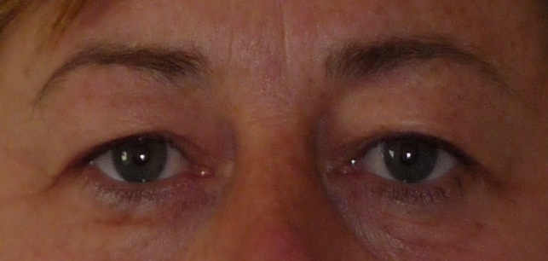 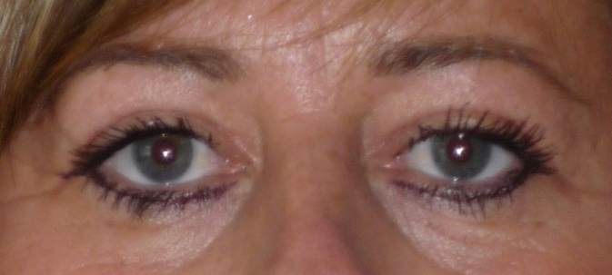

Result of Lower Blepharoplasty alone at 5 months.

With upper eyelid corrections (upper blepharoplasty) the aim of surgery is to reproduce the ideal shape and contour by removing excess skin and/or muscle and recontouring away fatty bulges. The surgery can be undertaken under either a local or a general anaesthetic and when undertaken alone is usually a daycase procedure. It usually takes about 1 hour to perform. Any deeper sutures are usually self-dissolving and the skin edges are usually approximated with a single suture that runs under the skin. This minimizes the risk of conspicuous scarring.

**The lower blepharoplasty**

A number of techniques are used in lower eyelid corrections. The procedure usually takes about 1¼ hours to undertake and can be performed either under general or local anaesthetic as a daycase procedure. The exact procedure that will be undertaken will be decided and discussed at the initial consultation. In most cases this will involve an incision just under the lash margin with elevation of the skin and / or muscle layer to the rim of the orbit.

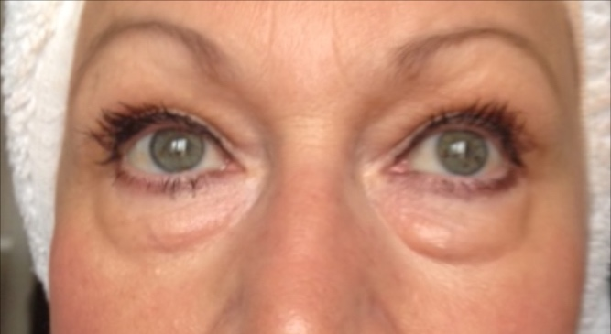 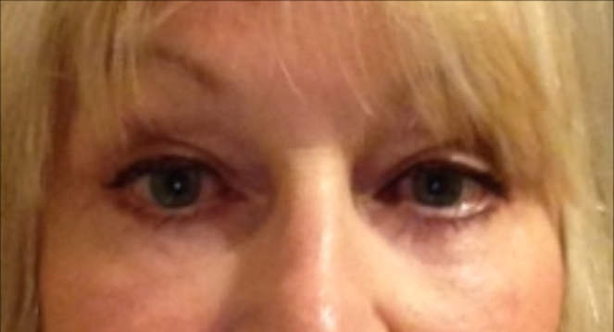

Result of lower eyelid correction at 10 days (patients may normally expect more bruising)

Occasionally a transconjunctival technique is employed with the incision situated within the inner aspect of the lower lid. The bagging may be treated by release of ligaments (the arcus marginalis and orbito-malar ligaments) allowing re-draping and recontouring, or by fat removal or by a combination of both. The aim is to provide a long lasting and natural effect and avoiding a hollowing out effect that occurred in the past with more aggressive fat removal techniques. At the same time the muscle may be tightened using a canthopexy technique (the muscle is sutured to the tissues around the orbital rim to elevate and support the lower lid) and skin excised as required. Any deeper sutures are usually self-dissolving and the skin edges are usually approximated with a single suture that runs under the skin. This minimizes the risk of conspicuous scarring.

When both upper and lower eyelid corrections are undertaken these are usually performed under general anaesthetic with a one night stay in hospital post operatively.

In some cases (especially when upper eyelid or facial surgery has additionally been performed) a self-dissolving stitch is placed in the outer aspect of the eyelid region to join the upper and lower eyelids together to help the eyelids heal in the correct position. This stitch, if present, usually dissolves after three to four days and the eyelids open up normally.

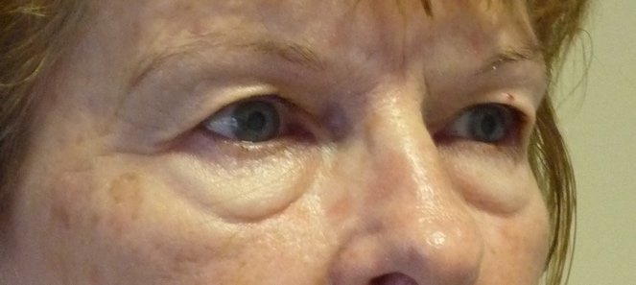 

Result of upper and lower eyelid corrections at 5 months

**Pre-operative advice.**

In order to optimize the result and minimize the risks a number of factors should be considered. Smokers have a much higher risk of developing complications. It is therefore advised that they should refrain from smoking for ideally four weeks prior to, and four weeks following surgery. Aspirin and related anti-inflammatories (other than those prescribed during the admission) should be avoided for one week before and 48 hours after surgery as these can significantly increase the risk of bleeding. Many supplements (gingko, ginger, turmeric, garlic) have anti-coagulant effects and therefore can increase the risk of bleeding and bruising and should be discontinued for a similar time period. The use of arnica is debatable with no clear evidence to support either its use or its avoidance.

The use of Botulinum toxin should be avoided before surgery as it can interfere with the eyebrow position and therefore the apparent upper eyelid skin excess. This makes it very difficult to determine the amount of skin that needs to be removed. Patients should therefore avoid Botulinum treatment for 3-6 months prior to surgery. They can have this treatment again 2-3 weeks following surgery.

When surgery is being undertaken under general anaesthetic it is recommended that patients on the combined oral contraceptive, and hormone replacement therapy, should stop these for four weeks prior to, and four weeks after surgery, as they may be associated with an increased risk of deep vein thrombosis (DVT). For patients on the pill alternative forms of contraception should be used.

Patients who are overweight also have a higher risk of complications. If patients are dieting, they should aim to get to their desired weight pre-operatively. Mr Cadier and his team have the policy that such surgery will only be offered to patients with a Body Mass Index (BMI) of less than 36. The BMI is calculated from the weight and height, and there are many simple tools available on the internet to help perform this calculation. Patients with a BMI of 36 or over have much higher risks both from the surgery and the anaesthetic and the risks therefore potentially outweigh the benefits.

**What happens before the operation?**

At the initial consultation with Mr Cadier after discussing regarding the specific concerns a full medical and surgical history will be obtained. As part of the consultation a psychological assessment is made to ensure that it is appropriate to undertake the surgery, and on occasions the completion of a psychological questionnaire may be required. In all cases Mr Cadier will write to the GP to request a past medical history. Patients may refuse this but need to be aware they are exposing themselves to more risks should they omit or forget some relevant past medical history. Also, in the post-operative period should there be any problems it is important that the GP is aware what has been undertaken in order to be able to offer effective help and advice. At the consultation details regarding the operation, the aims, the limitations, the recovery and the risks will be discussed. Before the operation you will usually attend for a pre-operative nurse led assessment. You may require a blood test. Any significant health problems not previously identified may be discussed with Mr Cadier or the anaesthetist, and a further assessment may be required to determine suitability for the procedure. At admission you will again be assessed by the nurses and you will be measured for a pair of compression stockings. These are worn to reduce the risk of thrombosis formation and should be worn for a minimum two weeks post-operatively. You will be seen by the anaesthetist prior to surgery and be able to discuss issues pertaining to the anaesthetic and also pain relief in the immediate post-operative period. You will also see Mr Cadier who may make some pre-operative markings and will take photographs for the medical records.

**What to expect immediately after the operation.**

Your blood pressure and pulse will be taken regularly following your return to the ward. You may have an intravenous infusion (a drip), which is usually removed once you are able to tolerate diet and fluids comfortably. If you experience any pain or discomfort following surgery painkillers are given either by injection or as tablets. Cool compresses are applied to the eyes and antibiotic ointment to the suture lines. The head end of your bed will be elevated to help reduce swelling.

**What to expect after discharge.**

Following surgery cold compresses will be applied to the eye region to reduce bruising and swelling. These compresses do not need to be kept in place permanently but the more they are used in the first twenty-four to forty-eight hours the more relief they will provide. The degree of swelling and bruising in the upper lids is very variable and usually persists for one to three weeks. The hideaway period is usually 7-10 days. In order to reduce the swelling patients are advised to use extra pillows and to keep themselves propped up at night for several days following surgery. Initially the eyes will feel tight and especially if other facial procedures have been undertaken. The tightness will resolve spontaneously though this may take several days and, on some occasions, several weeks. Eyelid closure is frequently affected at first and some patients may find that their blink mechanism is not entirely normal resulting in a feeling of dry eyes, sometimes with tearing and grittiness especially when exposed to cold air. This will usually resolve within a few days. Patients usually notice some numbness in the upper eyelid region following surgery, again this will resolve spontaneously but may take several months to fully correct.

**Pain relief.**

Eyelid corrections are not normally associated with significant pain, but should there be any pain simple analgesics such as Paracetamol may be used. Aspirin, Ibuprofen and other non-steroidal anti-inflammatories (unless specifically prescribed) should be avoided for the first 24 hours as they may increase bruising.

**Wound care and washing.**

Patients should avoid getting the wounds wet and should avoid disturbing them for the first few days following surgery. Tapes will be applied to keep the stitch ends in place. It is important that these tapes are left in place until suture removal occurs at seven days postoperatively. Hair washing with mild shampoos can be undertaken immediately. Makeup however should not be worn for at least one week following surgery and when makeup is first applied, care should be undertaken in view of the numbness of the eyelid skin. The scars in the eyelid corrections usually become very inconspicuous with 2-3 weeks and ultimately very difficult to see. The scar however extending from the outer aspect of the eyelid may remain red and sometimes lumpy for a few weeks following surgery. If lumpiness persists in this region, then gentle massage on a daily basis is advised.

**Glasses and contact lenses.**

Patients will not be able to use contact lenses for two to three weeks following surgery. Glasses can, however, be worn immediately though patients need to be careful to avoid disturbing the wound. Some change in the prescription may initially be noted as a result of swelling. This should fully correct over the first two to three weeks following surgery.

**Restrictions and activities.**

Patients are advised not to drive whilst the stitches are in place. Activities should be reduced for the first three to four weeks following surgery and vigorous activities such as golf and tennis, should be avoided for between six and eight weeks.

**Follow up.**

Patients will be reviewed for removal of sutures and wound checks by the nursing staff in the outpatient department 7 days following surgery. Patients will be reviewed by Mr Cadier at a minimum of one and five months postoperatively in the outpatients. Appointments for the wound check and suture removal will be given prior to discharge and appointments to see Mr Cadier in the outpatients will be sent via the post.

**Risks and complications.**

As with all surgical procedures complications may occur. With eyelids they are less common with upper eyelid corrections. Early identification and prompt identification is important and should patients have any cause for concern they should either contact the hospital or Mr Cadiers’ secretary. These risks include:

* Bleeding
* Haematoma
* Severe bruising
* Infection
* Persistent swelling
* Droopy upper eyelid (ptosis)
* Lagopthalmos (inability to close eyelids)
* Malposition and ectropion
* Conjunctival chemosis
* Eyelid crease asymmetry
* Diplopia (double vision)
* Wound dehiscence
* Dry eyes
* Scar problems including cysts and milia
* Medial canthal webbing
* Hyperpigmentation
* Changes in refraction and astigmatism
* Under and over correction
* Potential for revisional surgery
* Deep bleeding causing blindness
* Deep vein thrombosis and life-threatening pulmonary embolism
* Anaesthetic complications – these will be discussed with you by the anaesthetist before surgery.
* Death

Initially there may be some bleeding or oozing from the wound edge. This is normal. Some bruising is inevitable and occasionally it is marked. To reduce this patients can apply ice packs in the post-operative period, sleep with the head slightly elevated, avoid anything that raises the blood pressure (bending and lifting, not taking blood pressure tablets) or that promotes bleeding (aspirin or equivalent ant-inflammatory medication). Bleeding that results in a collection of blood requiring surgical removal (a haematoma) is rare. Infections can occur in any surgical wound but in upper eyelid corrections this is very rare (1:500). Should it occur either topical or oral antibiotics may be necessary.

Some swelling is inevitable and usually will have settled down to an acceptable degree within 1-2 weeks. Occasionally it is more prolonged. When this occurs the use of cool compresses, elevation and limiting activities may help. In some cases steroid eye drops can help, though care needs to be used with all eye drops as they themselves may be the cause of the problem as allergic responses to eye drops are not uncommon.

Drooping of the upper eyelid may occasionally occur. This is usually a temporary problem associated with bruising and swelling however, if it persists beyond 3-6 months surgical correction may be necessary. In most cases this is due to a preexisting drooping eyelid that will have been identified before surgery. The implications of these findings will be discussed at the pre-operative consultation.

Lagophthalmos or incomplete eyelid closure can occur following eyelid surgery as a result of scar formation or difficulties in estimating the amount of skin removal. In most cases it self corrects after a few weeks though rarely a secondary procedure is required. In most patients there will be factors that predispose them to this risk, and in some patients eyelid lagophthalmos may be present pre-operatively. Predisposing factors include large or protruding eyes, thyroid eye disease and previous blepharoplasty surgery. These factors are normally identified pre-operatively and the implications discussed at the initial consultation. Secondary surgery, including the use of skin grafts may be required.

The main cause for concern in lower eyelid corrections is the distortion of the eyelid shape which can result from excessive swelling or undesirable scarring under the eyelid skin. In some patients there may be factors that predispose them to this risk, and in some patient’s eyelid malposition may be present pre-operatively. Predisposing factors include lower eyelid laxity, large or protruding eyes, thyroid eye disease, loss of midface fullness and previous blepharoplasty surgery. As above these factors are normally identified pre-operatively and the implications discussed at the initial consultation. Should this distortion occur a pulling appearance is observed. This is termed eyelid malposition and may be associated with a rounded appearance in the outer aspect of the eyelid and visibility of the white of the eye under the iris. In the majority of cases this settles spontaneously though this may take several weeks. On occasions the pulling effect is marked, and the eyelid does not sit properly on the globe of the eye. This is termed an ectropion. Again, this usually settles spontaneously with the resolution of the swelling, but sometimes taping and / or massaging is required for several weeks post-operatively. If either of these problems persist a secondary surgical procedure may be required.

Conjunctival chemosis is a common problem following lower eyelid corrections but uncommon in upper eyelid corrections. A fluid filled area in the white of the eye is seen one or both sides of the iris. This may not cause any symptoms but in some patients may be associated with discomfort and drying of the eyes (by preventing eyelid closure), and in some may appear to push the lower eyelid forward. Most cases settle spontaneously after 1-3 weeks usually by using eyelid lubricants, and steroid eyedrops. Occasionally the sac can be snipped under local anaesthetic eye drops in the clinic setting. The upper eyelid has a crease usually 8-10mm above the lash margin, however this is very variable not only between patients but also between sides in the same patient. All attempts are made to place the scar within the crease at a symmetric position. Nonetheless it is not possible to get perfect symmetry and careful examination will always pick up subtle differences.

Double vision (Diplopia) is a very rare complication usually resulting from swelling around the muscles that move the eyeball. Occasionally it is due to direct trauma to the muscles as these are within the area being operated on. In most cases it settles spontaneously though this may take several weeks. Double vision occurring in one eye is as a result of changes in the tear film. Again, this is very rare and will settle spontaneously over a few weeks. Occasionally the wound edge may gape. Mostly this self corrects with no adverse effect. Sometimes the wound requires a tape to be applied and very rarely an additional suture. Temporary drying of the eyes is not uncommon for the first 1-3 weeks and is due to a transient disturbance of the blink mechanism. Artificial tears may be necessary. In some patients drying of the eyes is associated with a gritty feeling, in others excessive tearing may result. Occasionally dry eyes are prolonged. This is frequently associated with a pre-operative tendency to dry eyes. Prolonged use of artificial tears may be required and sometimes eye protection at night may be required for a short period.

The scars following upper eyelid corrections are usually very inconspicuous. Occasionally they become red and the scar to the side of the eyelid may become lumpy. These problems usually resolve fully, though sometimes massaging of the scars is required. Where the stitch comes out of the skin patients may see a very small white spot. This is termed a milia and it will resolve spontaneously without the need for any treatment. Small cysts can form in the scar 2-3 months after surgery. Again, these frequently resolve spontaneously but sometimes need to be treated in the out-patient setting. On the inner aspect of the upper eyelid scar a small web may develop when a lot of skin needs to be removed. These usually settle with massage though occasionally secondary surgery is required.

There are limits to what is achievable with eyelid corrections. In upper eyelid corrections the main aim is usually to correct hooding. Some asymmetry in the crease lines and positioning of the eyelid fold is normal. The position of the eyebrow is not usually affected by upper eyelid corrections. If there is an element of outer eyebrow droop, then this will still be present following the upper eyelid correction. A separate surgical procedure is required to elevate eyebrows. In the lower eyelids the aim is to correct the appearance of the lower eyelid at rest and in forward gaze. Wrinkles on animation are not corrected and minor contour irregularities and some asymmetries are normal. Malar bags (bags over the cheekbone) and festoons are not fully corrected with the routine lower eyelid corrections and additional procedures may be required.

Blindness is an extremely rare complication of upper eyelid corrections, with no cases having been reported in the UK on a recent survey (2011) of all BAAPS and BAPRAS members (these are the two organizations to which the majority of accredited Plastic Surgeons belong in the UK). Nonetheless this is a recognized complication with an incidence in the world literature of 1:10,000. Because in the majority of cases it is due to deep bleeding patients should avoid anything that raises the pressure in that area for a week following surgery. Patients should therefore refrain from excessive bending over or heavy lifting and should make sure that they continue with their anti-hypertensive medication unless otherwise directed.

Following any surgery there is a risk in developing a deep vein thrombosis (DVT). This is a clot in the calf vein of the leg. In itself it may result in pain and swelling. The risk is that should the clot separate from the vein it can move to the lungs resulting in a pulmonary embolism. This is a potentially life-threatening situation. All attempts are made to reduce the risk using compression stockings during and for two weeks after surgery, using pneumatic compression devices on the legs at surgery and in the immediate post-operative period, by encouraging early mobilization, advising patients to stop the combined oral contraceptive pill or Hormone Replacement Therapy (HRT) four weeks prior to surgery, and where it is felt appropriate using injections of blood thinning agents.

All surgical and anaesthetic procedures have risks, and some are life threatening, these include pulmonary embolism, anaphylaxis (severe allergic response to a medication) and adverse drug reactions. Death however remains an extremely rare complication.

Risks and complications will be discussed, and all efforts made to minimize any risks. Patient safety is always our first concern.

When complications do occur, all attempts are made not only to remedy the problem in as speedy a manner as possible but also to optimise the final result. As with all cosmetic surgical procedures undertaken by Mr Cadier, there is a fixed fee policy, which means that no further charges are incurred for the treatment of complications that are identified within 6 months following the initial surgery. Revisional policies for aesthetic concerns have changed and, in most cases, additional fees will be incurred. Patients need to be aware regarding the limitations of surgery and have very realistic expectations about outcomes.

Most patients are delighted with the result of surgery. The main effect is to brighten up the eyes, and in patients with hooding of the upper eyelids to reduce the tired look associated with this problem. The main effect of lower eyelid surgery is to take away the tired look, and by so doing provide a refreshing and rejuvenating look. A generalised rejuvenating effect is often also achieved. Eyelid corrections are usually very long lasting, and most patients seldom require any further surgery.

**Contact details:**

**Private Office:**

Address: 36 Batten Road, Downton, Salisbury, SP5 3HU

PA: **Nicola Haicalis**

Ph: **01725 511 550**

Fx: **01725 511 846**

Email: **nicola.haicalis@michaelcadier.com**

Website : **www.michaelcadier.com**

**Hospitals :**

**Nuffield Bournemouth**,67 Lansdowne Rd, Bournemouth Dorset, BH1 1RW.

Tel: 01202 291866

**About your Surgeon:**

Michael Cadier was educated at the French Lycée in London, studied at Oxford University and undertook Medicine at St Thomas’ Hospital, London. After training in London, Salisbury and Bristol he became an NHS Consultant in the Supra-regional Plastic Surgery Unit in Salisbury in 1996, becoming Head of this Service in 1999. In his NHS practice he developed a breast reconstruction service in Portsmouth, and in 2000 was appointed as cleft surgeon to the newly established Spires Cleft Centre, for which he also became the first Clinical Director in 2002. He undertook yearly cleft lip and palate Charity missions in rural Pakistan from 1996 to 2009. He has a busy aesthetic surgery private practice along the South Coast, undertaking the full range of aesthetic surgery procedures. He has performed over a thousand facelifts, and over 1500 breast augmentations, with similar numbers for all of the more common aesthetic procedures. In 2015 he became fully private, concentrating solely on aesthetic surgical practice.

He is widely published and lectures and teaches on aesthetic surgery both nationally and internationally. In 2006 he was invited to become an examiner for the FRCS (Plast). He is the Program Director for the South Coast Reconstructive Cosmetic Surgery Fellowship, was part of the first UK delegation in the CEN in cosmetic surgery (European regulation) and chaired the CSIC Royal College committee on Clinical Quality and Outcomes in Cosmetic Surgery.

The British Association of Aesthetic Surgeons (BAAPS) is the leading organization for aesthetic surgery in the UK. He was elected to BAAPS Council in 2006 and was President of BAAPS from 2014 to 2016. One of his key objectives is to ensure that UK plastic surgeons of the future will practice aesthetic surgery to the highest possible and with that aim he has helped establish a comprehensive national training program in aesthetic surgery.