Mr Michael Cadier

BA MA (Oxon) MBBS (London) MS (Soton), FRCSEd, FRCS (Plast) President of BAAPS 2014-2016
Consultant in Plastic, Reconstructive & Aesthetic Surgery

Correction of Gynaecomastia

Gynaecomastia - General Information.

Enlargement of the male breast is termed gynaecomastia. It is a common problem and usually results from hormonal imbalance. It occurs in over 50% of male adolescents, but in most cases resolves after 1-2 years. It also becomes more common in older age. When asymmetric or suddenly arising, other causes should be excluded, in particular drug therapy, liver and kidney problems and various tumours. In those who develop adolescent gynaecomastia that fails to resolve spontaneously the condition can be very embarrassing and significantly limit an individual’s activities – avoiding going on the beach or to pools and causing problems with relationships. Treatment for this type of gynaecomastia is surgical.

What procedures are available?

Gynaecomastia can be treated by a variety of techniques depending on the type of tissue causing the swelling – fatty or fibrous tissue, the extent of the swelling, and the amount of skin excess. The techniques employed include liposuction, excision of the breast bud (usually via an incision around the areola) or a combination of these. This is undertaken as either a day case or with a one night stay post-operatively under local or more commonly general anaesthesia.

Very occasionally when there is a lot of skin excess a formal breast reduction is required, with skin excision and nipple/areola repositioning.
Liposuction.

Correction of gynaecomastia using liposuction alone is a relatively straightforward procedure, which leaves a few usually inconspicuous scars, is low in risk and has a rapid recovery. The effect of liposuction alone will be limited if there is a significant fibrous component to the breast or if there is significant skin excess. Although techniques of ultrasound and laser assisted liposuction have over the years been proposed as means of removing the fibrous tissue and causing skin tightening the effect is very limited and there is a potential risk of damage to the skin, which may lead to scarring or skin loss.

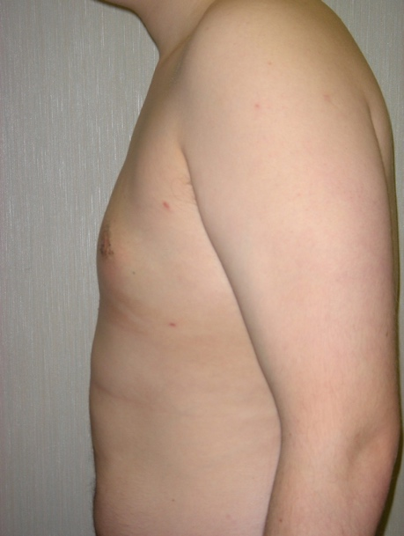
Before and after (4 weeks) photographs of gynaecomastia treated by liposuction alone.

Breast bud excision

When the breast tissue is fibrous (usually behind the areola) it may be necessary to directly excise the tissue through a hemi circular incision around the areola. In most cases liposuction
is undertaken at the same time. The wound is sutured with a dissolving stitch and the scar is normally very inconspicuous being at the junction of pigmented and non-pigmented skin. A
drain is frequently inserted; this being removed prior to discharge.

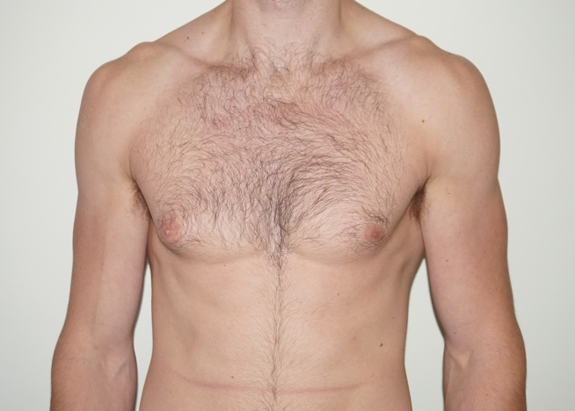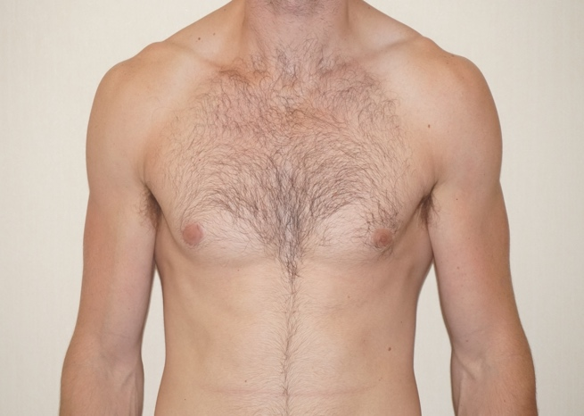
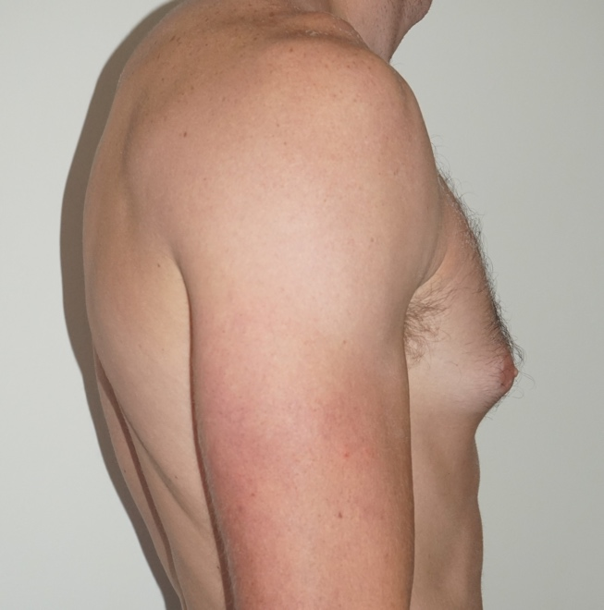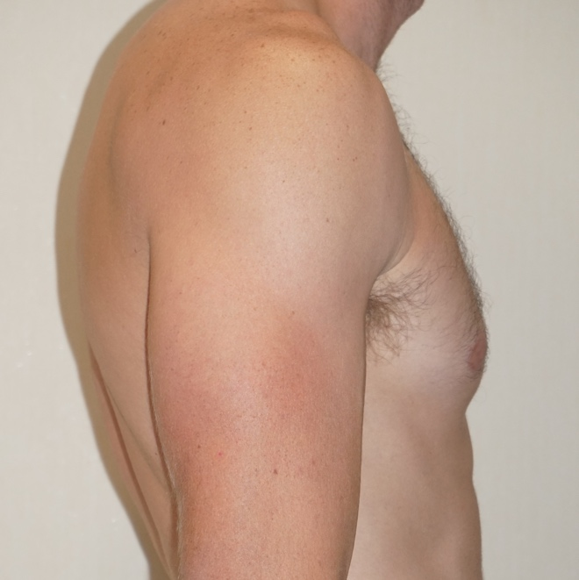
Before and after (4 weeks) photographs of gynecomastia treated by liposuction and breast bud excision.

Breast reduction.

In severe cases of gynaecomastia when there is a marked skin excess a formal breast reduction is required. In this procedure skin is excised and in most cases the nipple areola complex is moved upwards into a more normal position. There will inevitably be scars of the chest though their precise location will vary on the type of reduction required. In almost all cases drains are required and the hospital stay will be between 1 and 2 nights. This is rarely required as in most cases the alternative procedures work well.

Areola and nipple reduction.

When the areola is excessively large it can be reduced by excising a ring of tissue around it. The effect of this procedure may however be limited as the scar may stretch and in some instances the areola may stretch out again. Also, this technique is not suitable when the breast bud is being excised but can be combined with liposuction alone. When the nipples are excessively pointy or large a reduction can be performed. This is usually a straightforward procedure.

Pre-operative advice.

In order to optimize the result and minimize the risks a number of factors should be considered. Smokers have a much higher risk of developing complications. It is therefore advised that they should refrain from smoking for ideally four weeks prior to, and four weeks following surgery. Aspirin and related anti-inflammatories (other than those prescribed during the admission) should be avoided for one week before and 48 hours after surgery as these can significantly increase the risk of bleeding. Many supplements (gingko, ginger, turmeric, garlic) have anti-coagulant effects and therefore can increase the risk of bleeding and bruising and should be discontinued for a similar time period. The use of arnica is debatable with no clear evidence to support either its use or its avoidance. Patients who are overweight also have a higher risk of complications. If patients are dieting, they should aim to get to their desired weight pre-operatively. Mr Cadier and his team have the policy that such surgery will only be offered to patients with a Body Mass Index (BMI) of less than 36. The BMI is calculated from the weight and height, and there are many simple tools available on the internet to help perform this calculation. Patients with a BMI of 36 or over have much higher risks both from the surgery and the anaesthetic and the risks therefore potentially outweigh the benefits.

What happens before the operation?

At the initial consultation with Mr Cadier after discussing regarding the specific concerns a full medical and surgical history will be obtained. As part of the consultation a psychological assessment is made to ensure that it is appropriate to undertake the surgery, and on occasions the completion of a psychological questionnaire may be required. In all cases Mr Cadier will write to the GP to request a past medical history. Patients may refuse this but need to be aware they are exposing themselves to more risks should they omit or forget some relevant past medical history. Also, in the post-operative period should there be any problems it is important that the GP is aware what has been undertaken in order to be able to offer effective help and advice. At the consultation details regarding the operation, the aims, the limitations, the recovery and the risks will be discussed. Before the operation you will usually attend for a pre-operative nurse led assessment. You may require a blood test. Any significant health problems not previously identified may be discussed with Mr Cadier or the anaesthetist, and a further assessment may be required to determine suitability for the procedure.

At admission you will again be assessed by the nurses and you will be measured for a pair of compression stockings. These are worn to reduce the risk of thrombosis formation and should be worn for a minimum two weeks post-operatively. You will be seen by the anaesthetist prior to surgery and be able to discuss issues pertaining to the anaesthetic and also pain relief in the immediate post-operative period. You will also see Mr Cadier who may make some pre-operative markings and will take photographs for the medical records.

What to expect immediately after the operation

You may have suction drains these being used to help reduce fluid accumulation under the skin. Your blood pressure and pulse will be taken regularly following your return to the ward. You will have an intravenous infusion (a drip), which is usually removed once you are able to tolerate diet and fluids comfortably. If you experience any pain or discomfort following surgery painkillers are given either by injection or as tablets. After surgery you will usually need to wear a pressure garment. This helps to provide support, and also helps in the molding process, especially when liposuction has been undertaken. You will be advised to wear this pressure garment for six weeks post-operatively.
What to expect after discharge.

Your length of stay in hospital is variable and depends on many factors. With liposuction alone it may be a day case procedure, but when drains are employed following breast bud excision you may need an overnight stay. In this latter case dressings will be placed over the wounds. These dressings are usually left intact for 5-7 days following surgery unless they become messy, in which case they are changed prior to discharge. Patients are invited to re-attend 5-7 days post discharge for a wound check by the nursing staff and a change of dressings. These dressings can be removed at day 10-14 post operatively. From two to four weeks postoperatively (once the tapes have dropped off) the wound should be massaged once or twice a day with Vitamin E containing cream or lotion.

Any wounds that have been sutured should be kept dry for approximately ten days following surgery and during this period of time patients are advised to wash with a flannel. After this ten day period the patients can get the wound wet provided there are no significant wound problems. Prolonged soaking in a bath should be avoided for three weeks postoperatively.
Although the drains are usually removed before discharge, occasionally one drain is left in for an extra few days. You will then be asked to return to the hospital for removal of the drain. Occasionally following removal of the drains, fluid accumulates under the skin. This is called a seroma and may require aspiration in the outpatients on several occasions.

Some numbness around the chest is inevitable following the surgery. Although it will improve over time some permanent numbness around the scar will persist. Some bruising and some swelling are also inevitable. These increases with the magnitude of the procedure and are more pronounced when liposuction has been performed. The bruising usually resolves after 1-3 weeks, but the swelling may persist for longer. Using a pressure garment for a longer period is very occasionally required. At discharge a letter will normally be sent from the ward to your General Practitioner informing them of your admission and of the procedure undertaken. Patients are encouraged to keep their GPs informed however should they wish the admission to remain confidential please inform the ward staff and no communications will be sent.
What restrictions are their following surgery?

This depends on the procedure undertaken but for those who have undergone liposuction with breast bud excision the following applies. With liposuction alone the recovery will be quicker and where skin has been excised it will be longer. For the first week following surgery patients should rest and convalesce. They should refrain from driving or from undertaking any light activities. After this one-week period light gentle activities can be undertaken, gradually building up to normal over a 3-4 week period. However, heavy lifting or any vigorous sporting activities should be avoided for 1-2 months following surgery. Most patients refrain from work for one week, however in those with physical jobs or whom recovery is delayed an additional 1-2 weeks may be required.

What about pain relief?

The procedure are not normally associated with much pain. However, regular pain relief is advised for a few days following surgery (usually a combination of anti-inflammatory medication and Paracetamol or Paracetamol / Codeine mixes). These should be prescribed prior to discharge from the hospital. Following this period pain relief should be taken as required.

What are the risks?

The risks include:

- Reactions to tape or topical preparations
- Bleeding (hematoma)
- Fluid accumulation (seroma)
- Infection
- Poor wound healing
- Nipple loss (very rare)
- Breast asymmetry
- Breast contour and shape irregularities
- Unfavourable scarring, including hypertrophic and keloid scars
- Changes in nipple or breast sensation may be temporary or permanent
- Damage to deeper structures—such as nerves, blood vessels, muscles and lungs—can occur and may be temporary or permanent
- Fatty tissue found in the breast might die (fat necrosis)
- Persistent pain
- Possibility of revision surgery

- Deep vein thrombosis and life-threatening pulmonary embolism
- Anaesthetic complications – these will be discussed with you by the anaesthetist before surgery.
- Death

As with all surgical procedures there are risks. These are relatively low in incidence and most are relatively straightforward to treat. When any skin or breast bud excision has been undertaken
There is a risk of bleeding resulting in the accumulation of blood within the wound (a haematoma). In most cases this occurs within a few hours of surgery and most require surgical drainage. Infections can occur in any wounds and antibiotic therapy may be required.

Some altered sensation around the surgical site is inevitable. Occasionally the nipple/areola complex becomes numb. In many cases sensation will gradually return. Where a surgical incision has been made there will be a scar. In most cases they are inconspicuous (especially when at the areola/chest skin junction), however some patients develop red and raised scars (hypertrophic scars). These may require additional treatments to reduce their extent (steroid injections, silicone gel therapy).

When a scar is placed around the areola some distortion of areola shape may occur – this is much more common when an areola reduction has been performed. Revisional surgery may be beneficial.

By far the commonest problems following gynaecomastia correction are contour anomalies. These may result from either under or over correction, adverse scarring or pre-existing contour disturbance. When significant revisional surgery may be beneficial. Although all attempts are made to try to produce a balanced result some differences between the two sides is almost inevitable as no one is perfectly symmetric, either in their underlying bone structure, muscle shape and size or fat distribution.

Following any surgery there is a risk in developing a deep vein thrombosis (DVT). This is a clot in the calf vein of the leg. In itself it may result in pain and swelling. The risk is that should the clot separate from the vein it can move to the lungs resulting in a pulmonary embolism. This is a potentially life-threatening situation. All attempts are made to reduce the risk using compression stockings during and for two weeks after surgery, using pneumatic compression devices on the legs at surgery and in the immediate post-operative period, by encouraging early mobilization, and where it is felt appropriate using injections of blood thinning agents.

All surgical and anaesthetic procedures have risks, and some are life threatening, these include pulmonary embolism, anaphylaxis (severe allergic response to a medication) and adverse drug reactions. Death however remains an extremely rare complication.

Risks and complications will be discussed, and all efforts made to minimize any risks. Patient safety is always our first concern.

When complications do occur, all attempts are made not only to remedy the problem in as speedy a manner as possible but also to optimise the final result. As with all cosmetic surgical procedures undertaken by Mr Cadier, there is a fixed fee policy, which means that no further charges are incurred for the treatment of complications that are identified within 6 months following the initial surgery. Revisional policies for aesthetic concerns have changed and, in most cases, additional fees will be incurred. Patients need to be aware regarding the limitations of surgery and have very realistic expectations about outcomes.

Most patients are delighted with the result of surgery. Many patients experience a huge boost in their self-confidence and self-esteem and gynaecomastia correction is associated with very high patient satisfaction rates.

Contact details:

Private Office:

Address: 36 Batten Road, Downton, Salisbury, SP5 3HU
PA: Nicola Haicalis
Ph: 01725 511 550
Fx: 01725 511 846
Email: nicola.haicalis@michaelcadier.com

Website : www.michaelcadier.com

Hospitals :

Nuffield Bournemouth, 67 Lansdowne Rd, Bournemouth Dorset, BH1 1RW.
Tel: 01202 291866

Spire Southampton Hospital, Chalybeate Close, Southampton, Hampshire, S016 6UY.
Tel : 02380 775544

About your Surgeon:

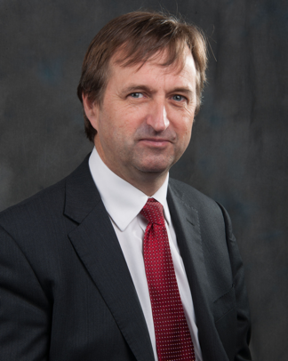
Michael Cadier was educated at the French Lycée in London, studied at Oxford University and undertook Medicine at St Thomas’ Hospital, London. After training in London, Salisbury and Bristol he became an NHS Consultant in the Supra-regional Plastic Surgery Unit in Salisbury in 1996, becoming Head of this Service in 1999. In his NHS practice he developed a breast reconstruction service in Portsmouth, and in 2000 was appointed as cleft surgeon to the newly established Spires Cleft Centre, for which he also became the first Clinical Director in 2002. He undertook yearly cleft lip and palate Charity missions in rural Pakistan from 1996 to 2009. He has a busy aesthetic surgery private practice along the South Coast, undertaking the full range of aesthetic surgery procedures. He has performed over a thousand facelifts, and over 1500 breast augmentations, with similar numbers for all of the more common aesthetic procedures. In 2015 he became fully private, concentrating solely on aesthetic surgical practice.

He is widely published and lectures and teaches on aesthetic surgery both nationally and internationally. In 2006 he was invited to become an examiner for the FRCS (Plast). He is the Program Director for the South Coast Reconstructive Cosmetic Surgery Fellowship, was part of the first UK delegation in the CEN in cosmetic surgery (European regulation) and chaired the CSIC Royal College committee on Clinical Quality and Outcomes in Cosmetic Surgery.

The British Association of Aesthetic Surgeons (BAAPS) is the leading organization for aesthetic surgery in the UK. He was elected to BAAPS Council in 2006 and was President of BAAPS from 2014 to 2016. One of his key objectives is to ensure that UK plastic surgeons of the future will practice aesthetic surgery to the highest possible standard and with that aim he has helped establish a comprehensive national training program in aesthetic surgery.

