Mr Michael Cadier

BA MA (Oxon) MBBS (London) MS (Soton), FRCSEd, FRCS (Plast) President of BAAPS 2014-2016
Consultant in Plastic, Reconstructive & Aesthetic Surgery

FACE AND NECK LIFTS

The ageing process

As we get older, a number of changes occur in the face and neck. In the 30’s and 40’s, repeated contraction of the muscles causes creases to occur in the skin. These occur predominantly around the eyes, between the eyebrows, in the forehead and in the lips. In the 40’s and 50’s, gravity starts pulling the soft tissues off the facial skeleton resulting in jowling, cheek sag, the development of nasolabial folds and lines around the corner of the mouth. The eyebrows may start to sag especially in the outer aspect. In the neck, the skin may sag, and bands may develop. With increasing age, the fat in the face may atrophy and result in hollowing of the cheeks and temples. The skin also ages becoming thinner and less elastic. Sun damage may lead to the development of sun spots and blotches.

Why some people age faster than others is due to a variety of factors. Smoking and repeated sun exposure is certainly very damaging, and maintaining a healthy lifestyle helps. However, both genetic and anatomical factors are also important. A wide variety of surgical procedures have been developed to help in facial rejuvenation and the key ones are described below.

What types of surgical procedures are available?

Face and neck lift procedures are always tailored to the patients’ individual requirements. Broadly, there are five main types recommended by Mr Cadier: the submental correction alone, the minilift, the lower facelift alone, the lower face and necklift, and the lower face and necklift with submental correction. In all of the face and neck lifts the operation involves both tightening and repositioning of the deeper tissues, the so-called SMAS layer (the superficial muscular aponeurotic system), as well as tightening and re-positioning of the skin. This two-layered approach creates a more natural effect and prolongs the effectiveness of the facelift. It also allows the deep tissues and skin to be tightened in different directions, allowing the specific problems (deep tissue sag causes the jowls, and skin laxity causes the wrinkles and folds) to be treated separately.

Other procedures may also be required as part of the face and neck lift, these include liposuction of the fat under the chin or in the jowls or cheeks; or fat transfer into areas of volume loss such as the cheeks and temples, or in folds such as the nasolabial or marionette areas. Various additional procedures can be undertaken to supplement the face and neck lifts, including brow-lifting, eyelid corrections, upper lip lifting and facial skin resurfacing with either a chemical peel or dermabrasion techniques.

Submental correction by direct skin/fat excision

In patients concerned solely about submental excess (frequently with a flap of skin under the chin) and who do not wish to undergo a face or neck lift then a submental correction may be appropriate. In this operation skin and fat is removed by direct excision leaving a scar underneath the chin. This procedure takes about 45 minutes to perform either under local or general anaesthesia as a daycase. The procedure does not correct the jowls or jawline, nor does it correct facial or neck sag. It can however, be a very effective treatment for submental skin excess. The trade-off is a scar under the chin.

The Minilift (Pre-auricular skin excision)

This is an operation undertaken when only a small effect is desired, or when other facelift procedures are contra-indicated, as in the very elderly. It may also be performed for patients who have already had a face lift in whom some recurrence has occurred but where a full repeat would not be appropriate. It is usually undertaken under local anaesthesia, as a daycase procedure. The incision is situated in front of the ear and the facial skin tightened by simple excision of skin from in front of the ear.

The lower facelift

Over the past decade there has been an increasing awareness of the limitations of facelifts, in particular relating to a tight look that can sometimes result and also concern regarding excessive dissection and potential complications that can result. Additionally, in younger patients the backward pull of the facelift is not required with a more desirable effect being achieved by an upwards repositioning of the soft tissues of the face with little tissue excision (this is called the volumetric approach). The MACS lift was designed with these concepts in
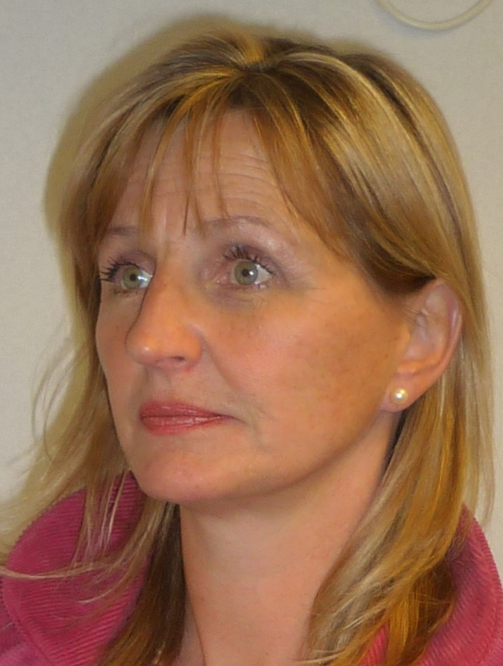
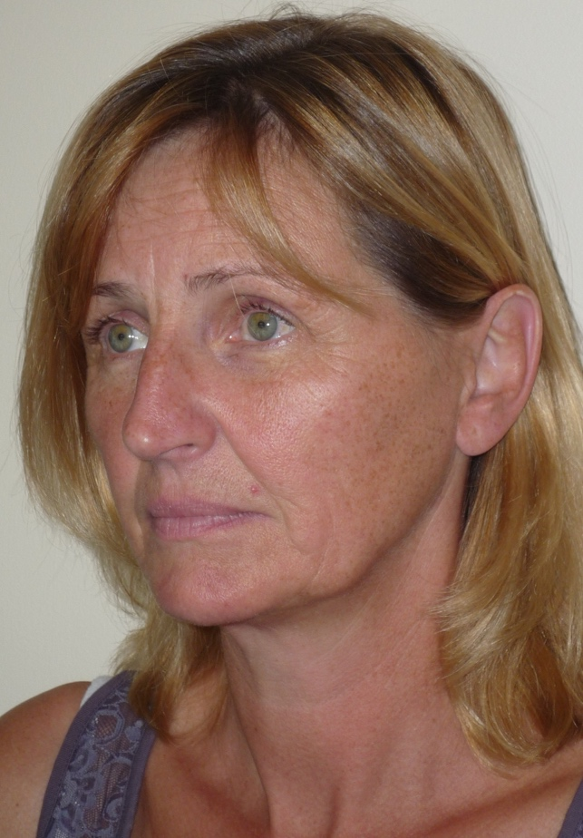

Photographs pre and 5 months following a lower facelift alone.

mind. It is undertaken via an S-shaped incision running under the sideburn area, in front of the ear and extending in the crease behind the ear. The soft tissues of the cheeks and the jawline are repositioned (SMAS-plasty) using sutures that are anchored to rigid tissue in the temple region (cranial suspension sutures). The MACS facelift is not suitable for all patients and tends to be restricted to a younger patient where a more limited procedure is appropriate. It has a very limited effect on the neck but will correct facial sag and mild jowling and achieve a good jawline contour. It takes about 2 hours to perform, is usually undertaken under general anaesthesia and requires a 1 night stay in hospital post-operatively. In patients with a round or plump face this technique is not suitable as it may increase the roundness. Likewise, in a very thin patient the suspension sutures may show. For these patients and in those undergoing a second facelift other SMAS manipulations may be preferable and include SMAS-ectomies, SMAS flaps and SMAS plications.

The necklift alone

The necklift alone aims to correct neck sag and submental excess. It has minimal effect on jowling, and facial sag and most patients will opt to have it combined with the lower facelift as described below. When undertaken alone the incision starts in front of the ear hugging the natural contours. It then goes around the earlobe into the crease behind the ear up to the top of the bald patch behind the ear, then down the hairline for 2-3cms and then finally back into the hair bearing scalp. The skin and muscle of the neck is elevated and where appropriate a submental correction is performed. This can involve liposuction, direct fat removal or a medial platysmoplasty. These are described more fully in the next section. The necklift takes about 2 hours to perform, is usually undertaken under general anaesthesia and requires a 1 night stay in hospital post-operatively.

The lower face and necklift

The lower facelift alone, although an excellent operation for selected patients, is very limited in its effect on the neck – so often a source of facial ageing. In most patients requiring facial rejuvenation the lower face and necklift is the most appropriate procedure. The incision starts under the sideburn region then goes down in front of the ear hugging the natural contours. It then goes around the earlobe into the crease behind the ear up to the top of the bald patch behind the ear, then down the hairline for 2-3cms and then finally back into the hair bearing scalp. The part of the incision in front of the ear allows for the facelift, and that behind the ear the necklift. The skin and deep tissues are treated separately. The facial soft tissues are treated by a SMAS manipulation as described above. The neck soft tissues are treated using a lateral platysmal suspension. The skin tightening is undertaken in a direction specific to the patient’s needs. This technique is adjusted in all patients with, in some cases the necklift component being favoured over the facelift or vice versa.

When there is significant submental soft tissue excess or with platysmal bands a submental correction can be additionally performed. This involves a concealed incision under the chin. The fat can be removed by a combination of direct excision (lipectomy) and liposuction, and the platysma treated by a medial platysmoplasty. Occasionally the digastric muscles if overly large are trimmed and on very rare occasions the submandibular salivary glands can be partially resected, though in most this is not performed as not only does it significantly increase the risks (especially of bleeding and nerve injury) but it can give an over corrected look.

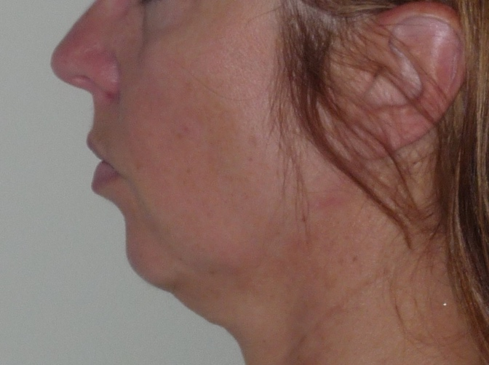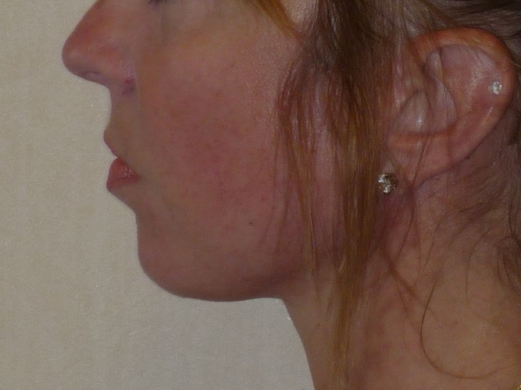

Photographs pre and 5 months following lower face and neck lift with submental liposuction

The procedure takes about 2 ½ hours to perform and is usually undertaken under general anaesthesia and requires a 1 night stay in hospital post-operatively.

Lower Face and Neck lifts in men

In many respects the operation is very similar in men and women. In men the scars cannot be so easily concealed as most men have short hair. In order to reduce scar visibility, the incisions under the sideburns are more limited and even more so behind the ears. This means that the effectiveness is slightly reduced. Additionally, the beard bearing skin will be elevated and shaving behind the lower part of the ears may be required.

Additional procedures that may be required

A variety of other procedures may be undertaken at the same time. Although there is an increase in the operating time, the hospital stay is usually the same. Facial fat grafting may be performed. In this technique, fat is harvested usually from the upper inner thighs using very fine liposuction-like cannulas. The harvested fat is then cleaned and centrifuged, and the purified fat can be injected into various areas, most commonly the nasolabial folds, the marionette lines, the cheeks or the lips. This enables filling with one’s own body tissue. Fat graft uptake can be variable, although it usually works well in the folds and cheeks. If this is successful, this will lead to a permanent correction. In the lips, graft uptake is far more variable. Other additional procedures include brow lifting, upper and lower eyelid corrections, upper lip length shortening, earlobe reductions and facial skin resurfacing using either a chemical peel or dermabrasion technique.

Pre-operative advice.

In order to optimize the result and minimize the risks a number of factors should be considered. Smokers have a much higher risk of developing complications. It is therefore advised that they should refrain from smoking for ideally four weeks prior to, and four weeks following surgery. Aspirin and related anti-inflammatories (other than those prescribed during the admission) should be avoided for one week before and 48 hours after surgery as these can significantly increase the risk of bleeding. Many supplements (gingko, ginger, turmeric, garlic) have anti-coagulant effects and therefore can increase the risk of bleeding and bruising and should be discontinued for a similar time period. The use of arnica is debatable with no clear evidence to support either its use or its avoidance.

It is recommended that patients on the combined oral contraceptive, and hormone replacement therapy, should stop these for four weeks prior to, and four weeks after surgery, as they may be associated with an increased risk of deep vein thrombosis (DVT). For patients on the pill alternative forms of contraception should be used.

Patients who are overweight also have a higher risk of complications. If patients are dieting, they should aim to get to their desired weight pre-operatively. Mr Cadier and his team have the policy that such surgery will only be offered to patients with a Body Mass Index (BMI) of less than 36. The BMI is calculated from the weight and height, and there are many simple tools available on the internet to help perform this calculation. Patients with a BMI of 36 or over have much higher risks both from the surgery and the anaesthetic and the risks therefore potentially outweigh the benefits.

What happens before the operation?

At the initial consultation with Mr Cadier after discussing regarding the specific concerns a full medical and surgical history will be obtained. As part of the consultation a psychological assessment is made to ensure that it is appropriate to undertake the surgery, and on occasions the completion of a psychological questionnaire may be required. In all cases Mr Cadier will write to the GP to request a past medical history. Patients may refuse this but need to be aware they are exposing themselves to more risks should they omit or forget some relevant past medical history. Also, in the post-operative period should there be any problems it is important that the GP is aware what has been undertaken in order to be able to offer effective help and advice. At the consultation details regarding the operation, the aims, the limitations, the recovery and the risks will be discussed. Before the operation you will usually attend for a pre-operative nurse led assessment. You may require a blood test. Any significant health problems not previously identified may be discussed with Mr Cadier or the anaesthetist, and a further assessment may be required to determine suitability for the procedure.

At admission you will again be assessed by the nurses and you will be measured for a pair of compression stockings. These are worn to reduce the risk of thrombosis formation and should be worn for a minimum two weeks post-operatively. You will be seen by the anaesthetist prior to surgery and be able to discuss issues pertaining to the anaesthetic and also pain relief in the immediate post-operative period. You will also see Mr Cadier who may make some pre-operative markings and will take photographs for the medical records.

The operative procedure

The face and necklift operations are usually performed under a general anaesthetic and take 2-3 hours to perform. The incisions are designed so as to produce scars that are either concealed (in the hair-bearing scalp and behind the ears) or in an area which normally leaves very inconspicuous scarring. The facial tissues are tightened in layers and any additional procedures are undertaken. The sutures in front of the ears and any metal staples in the hair bearing scalp require removal at 14 days post-operatively. All of the other sutures used are usually self-dissolving. Cold moist gauze is applied to the face to reduce swelling and a compression bandage applied. One dose of antibiotic is given at operation to reduce the risk of infection and one dose of steroid to reduce postoperative swelling.

What to expect immediately after the operation

Your blood pressure and pulse will be taken regularly following your return to the ward. You will have an intravenous infusion (a drip) which is usually removed after 24 hours once you are able to tolerate diet and fluids comfortably. If you experience any pain or discomfort following surgery painkillers are given either by injection or as tablets. For the first 24 hours most patients will rest. Swelling is reduced by keeping the head elevated and by applying cold compresses to the face. Patients are usually discharged the next day. Prior to discharge the dressings are removed and the hair is washed. A head band is usually provided and depending what procedures were undertaken may need to be worn for 2 weeks, day and night, postoperatively and then for a further 1-4 weeks at night only.

What to expect after discharge.

Some patients develop bruising immediately following surgery, in others it develops after 2 - 3 days. Associated with this bruising there will be swelling of the face which may initially be marked and frequently gives the face a round appearance. The bruising usually resolves within 1 - 2 weeks, but the facial swelling may persist for another 2 - 3 weeks. The usual hideaway period following facelift and necklift surgery is approximately 10 - 14 days, though this may be longer depending on the degree of bruising and swelling. Some oozing from the wounds is inevitable in the first 48 hours following surgery and it is therefore advisable to use some protection at night over the pillow.

Some patients will also notice some lumpiness and irregularity of the skin which may be more marked on one side compared to the other. Any lumpiness of the skin is usually as a result of some deep bruising. This will usually resolve and not be visible at about 1 - 2 weeks following surgery though some palpable lumpiness may persist for two or three months. Gentle massaging of these areas 2 - 3 weeks after surgery may speed up their resolution. Although many of the effects of the facelift surgery are apparent immediately, patients need to wait for at least 3 - 6 months to judge the final result.

Patients will often note that the face feels very tight and initially this is aggravated by opening and closing the mouth and by turning the head. This tightness usually resolves within a few days. Additionally, patients frequently notice numbness in the cheek region and the ears. This is normal but will gradually resolve usually within 2 - 3 months.

Pain relief

Most patients do not experience significant pain following face and necklift surgery. It is however beneficial to take pain relief for the first week following surgery, often on a regular basis to avoid any breakthrough pain. Beyond this period of time, pain relief only as required is necessary. In the first 48 - 72 hours following face and necklift surgery, it is preferable to avoid Aspirin and equivalent anti-inflammatory agents as they may increase bruising. A small subgroup of patients experience prolonged tightness and pain – sometimes for several months. Why this occurs is unknown but may be a form of causalgia in which the small sensory nerves react to the surgery in an anomalous way. Although this will always settle occasionally additional anti causalgia medication may be required.

Sleep advice

Sleep is a very important part of the recovery process and it is important that a good night’s sleep is obtained. On the night following surgery, sleeping tablets are prescribed and a short course may be necessary for a few days. Sleeping with the head elevated by using an extra pillow or two may help reduce swelling and can be beneficial for the first few days following surgery.

Washing

The face can be gently cleaned from about 4 days following surgery. Light cleansers and moisturizers can be used at one week as well as light makeup. At two weeks following surgery, all products may be used unless there is persistent marked swelling. Hair-washing with simple shampoos can be undertaken from discharge, although care needs to be taken around the areas where stitches are present.

Restrictions and activities

Patients are discouraged from driving for one week following surgery and will need to be off work for between 1 - 3 weeks. Patients should avoid any facials, hair dyeing or perms, eyebrow plucking or waxing or any equivalent treatments for at least 4 - 6 weeks following surgery. Patients who wear contact lens may find it difficult to insert them for the first week following surgery (or longer if eyelid corrections have been undertaken), glasses can be worn immediately although some care around the suture sites is necessary. Light activities including gym work and swimming should be avoided for about 4 weeks following surgery and any sporting activities where violent movement may occur (including golf and tennis) should be avoided for between 6 - 8 weeks.

Follow up

Patients will be reviewed for wound checks and removal of sutures by the nursing staff in the outpatient department at 1 and 2 weeks following surgery. Patients will be reviewed by Mr Cadier at a minimum of one and five months postoperatively in the outpatients. Appointments for the wound checks and suture removal will be given prior to discharge and appointments to see Mr Cadier in the outpatients will be sent via the post.

Risks and complications

As with all surgical procedures, complications may occur. Early identification and prompt intervention are important, and should patients have any cause for concern they should either contact the hospital or Mr Cadier’s Secretary.

Complications include the following:
- Haematoma
- Prolonged swelling
- Persistent lumpiness
- Seroma
- Infection
- Skin flap necrosis
- Hypertrophic or poor scarring
- Alopecia
- Hairline deformities
- Earlobe deformities
- Asymmetry
- Recurrent sag
- Sensory Nerve injuries
- Chronic pain and tightness
- Motor Nerve injuries
- Potential for revision

  - Deep vein thrombosis and life-threatening pulmonary embolism
  - Anaesthetic complications – these will be discussed with you by the anaesthetist before surgery.
  - Death

In the first few hours following return to the ward, bleeding may occur under the cheek skin resulting in an accumulation of blood (a haematoma) which, in most cases, requires a return to the operating theatre for removal of the haematoma, cautery and re-suturing. The risk of this complication (normally about 1 in 100 cases) is significantly increased if the patient has a poorly controlled blood pressure, has taken non-steroidal anti-inflammatories (Ibuprofen, Aspirin) or is a smoker. The risk is higher in males.

Persistent swelling may occur in some patients for no specific reason. In addition to keeping the head elevated at night and applying cool compresses, occasionally a short course of anti-inflammatories or steroids is required. Additionally, some patients experience a lot of tightness especially around the neck which may take 2-3 weeks to resolve. Prolonged pain or tightness may be as a result of causalgia – as described in the section on pain relief.

Some lumpiness may be felt in the first 1-3 weeks following surgery. In most cases this settles spontaneously and is probably due to deep bruising. If this is persistent additional treatment, usually an injection of steroid into the area may be required. Occasionally it is due to a small accumulation of blister like fluid under the skin – this can be easily aspirated in clinic.

Infections can occur in any wound and with facelifts this is most common behind the ears and in the hairline. Sometimes topical or oral antibiotics are required. Very rarely infections can occur in the deeper tissues and may cause localized areas of skin damage, usually behind the ears, but occasionally in the cheeks. These areas of skin damage can also be caused by small unrecognized haematomas. Most of the time these resolve and heal with minimal problems though occasionally a minor scar revision is required.

The skin flaps that are raised during the operation require a blood supply to survive. When the blood supply is compromised part of the skin flap may die (skin flap necrosis) and a scab will form which may heal by itself or may require surgical treatment. This is a rare complication and can be caused by a variety of problems including an unrecognised tense haematoma, a severe infection, patient factors (diabetes, advanced age) and the application of excessive cold (ice burns). Often it is a combination of factors.

The facelift incisions are designed to render the scars very inconspicuous and this is the case in the majority of patients. Occasionally, in some patients, the scars, especially those behind the ears, become red and lumpy (hypertrophic). Whilst these usually settle down with time occasionally extra treatments such as steroid injections may be recommended. When the facelift incision has been minimized, as in the MACS or modified MACS lift procedure, or in males when all attempts are made at keeping the scars around the ears alone with no extension into the hairline, some puckering of the scar in the crease behind the ear may occur. In most cases, this will settle by itself over a few weeks, but in some cases a minor revision is required, usually under a local anaesthetic, as a day case procedure. Although usually pale and difficult to see the scars may be red or pale. Some minor alopecia or hair loss around the scars in the hairline is very common. In most cases it is totally inconspicuous. Sometimes there are patches of hair loss but in most cases the hair grows back over a 3 - 6 month period. Some disturbance of the hairline behind the ears is inevitable though in most cases it is inconspicuous. Earlobes come in a variety of shapes and sizes and all attempts are made to maintain their pre-operative shape (unless a change is specifically requested). Some pulling on the earlobe may occur reducing the drop of the earlobe and when marked pulling the earlobe down – a pixie ear deformity. A surgical revision may be required.

Faces are never symmetric and post-operatively some asymmetry is inevitable. Patients may notice this more following surgery as they will tend to scrutinize their faces.

Although the effects of face and neck lifts are long lasting, with the effect still being maintained for many years some recurrent sagging of the tissues is inevitable and expectations have to be realistic. With older patients and when the changes are marked the degree of recurrence is greater. There is a limit to what is achievable in all facial rejuvenation procedures. Face and necklifts work best in correcting jowling, recontouring the jawline, softening the nasolabial folds, improving facial sag and correcting neck sag. Areas that all less well corrected are the marionette lines, the small folds that sometimes occur in front of the jowl area and bands in the neck. The aims and expectations as well as the limitations of surgery will be discussed in detail pre-operatively.

Temporary numbness in the cheeks and ears is a normal finding following facelift surgery. Occasionally the numbness in the ear may be marked and can be long lasting. This may be due to bruising or damage to the greater auricular nerve, a large nerve in the neck that supplies sensation to the ear. In most cases this will resolve spontaneously, but this process may take many months.

Very rarely patients experience prolonged tightness and discomfort. This is a rare complication of all surgery and is akin to causalgia. It is probably due to sensory nerve disturbance and may require medication to help it settle.

A rare complication following a facelift procedure is of interference with the facial nerve function, this being a nerve that supplies all the muscles within the face for expression. Should this complication occur patients will notice that one side of the mouth or eyebrow does not move properly. Fortunately, in the vast majority of cases, this is a temporary phenomenon which will resolve within a few weeks of surgery.

Following any surgery there is a risk in developing a deep vein thrombosis (DVT). This is a clot in the calf vein of the leg. In itself it may result in pain and swelling. The risk is that should the clot separate from the vein it can move to the lungs resulting in a pulmonary embolism. This is a potentially life-threatening situation. All attempts are made to reduce the risk using compression stockings during and for two weeks after surgery, using pneumatic compression devices on the legs at surgery and in the immediate post-operative period, by encouraging early mobilization, advising patients to stop the combined oral contraceptive pill or Hormone Replacement Therapy (HRT) four weeks prior to surgery, and where it is felt appropriate using injections of blood thinning agents.

All surgical and anaesthetic procedures have risks, and some are life threatening, these include pulmonary embolism, anaphylaxis (severe allergic response to a medication) and adverse drug reactions. Death however remains an extremely rare complication.

Risks and complications will be discussed, and all efforts made to minimize any risks. Patient safety is always our first concern.

When complications do occur, all attempts are made not only to remedy the problem in as speedy a manner as possible but also to optimise the final result. As with all cosmetic surgical procedures undertaken by Mr Cadier, there is a fixed fee policy, which means that no further charges are incurred for the treatment of complications that are identified within 6 months following the initial surgery. Revisional policies for aesthetic concerns have changed and, in most cases, additional fees will be incurred. Patients need to be aware regarding the limitations of surgery and have very realistic expectations about outcomes.

It should be emphasized that most patients are delighted with the result of surgery, which in turn helps to improve their confidence and self-esteem. Many patients receive positive comments from friends and colleagues telling them that they appear well, look fresher and less tired, without people guessing that this is the result of a surgical procedure. The aim is to produce a natural looking and rejuvenating effect without signs of surgery.

Contact details:

Private Office:

Address: 36 Batten Road, Downton, Salisbury, SP5 3HU
PA: Nicola Haicalis
Ph: 01725 511 550
Fx: 01725 511 846
Email: nicola.haicalis@michaelcadier.com

Website : www.michaelcadier.com

Hospitals :

Nuffield Bournemouth, 67 Lansdowne Rd, Bournemouth Dorset, BH1 1RW.
Tel: 01202 291866

About your Surgeon:

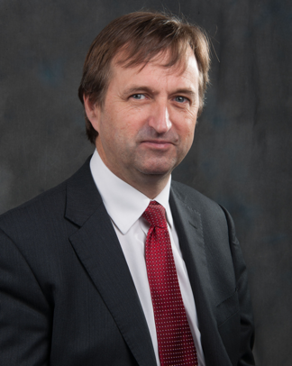
Michael Cadier was educated at the French Lycée in London, studied at Oxford University and undertook Medicine at St Thomas’ Hospital, London. After training in London, Salisbury and Bristol he became an NHS Consultant in the Supra-regional Plastic Surgery Unit in Salisbury in 1996, becoming Head of this Service in 1999. In his NHS practice he developed a breast reconstruction service in Portsmouth, and in 2000 was appointed as cleft surgeon to the newly established Spires Cleft Centre, for which he also became the first Clinical Director in 2002. He undertook yearly cleft lip and palate Charity missions in rural Pakistan from 1996 to 2009. He has a busy aesthetic surgery private practice along the South Coast, undertaking the full range of aesthetic surgery procedures. He has performed over a thousand facelifts, and over 1500 breast augmentations, with similar numbers for all of the more common aesthetic procedures. In 2015 he became fully private, concentrating solely on aesthetic surgical practice.

He is widely published and lectures and teaches on aesthetic surgery both nationally and internationally. In 2006 he was invited to become an examiner for the FRCS (Plast). He is the Program Director for the South Coast Reconstructive Cosmetic Surgery Fellowship, was part of the first UK delegation in the CEN in cosmetic surgery (European regulation) and chaired the CSIC Royal College committee on Clinical Quality and Outcomes in Cosmetic Surgery.

The British Association of Aesthetic Surgeons (BAAPS) is the leading organization for aesthetic surgery in the UK. He was elected to BAAPS Council in 2006 and was President of BAAPS from 2014 to 2016. One of his key objectives is to ensure that UK plastic surgeons of the future will practice aesthetic surgery to the highest possible standard and with that aim he has helped establish a comprehensive national training program in aesthetic surgery.

