Mr Michael Cadier

BA MA (Oxon) MBBS (London) MS (Soton), FRCSEd, FRCS (Plast) President of BAAPS 2014-2016
Consultant in Plastic, Reconstructive & Aesthetic Surgery

Prominent ear correction

Prominence of the ears is a cause of social embarrassment and may be surgically corrected. The two commonest problems are the failure of the anti-helical fold in the ear to develop or of the bowl (conchae) of the ear being too large. The surgery can be undertaken either in childhood from the age of 6 years onwards or in adulthood. It may be undertaken either under general anaesthesia or local anaesthesia and is usually performed as a day-case procedure.

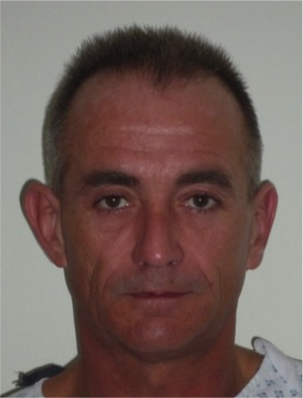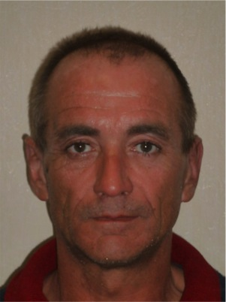
Pre and 6 month post operative views after prominent ear corrections.

What types of surgical procedures are available?

There are many different techniques described with the two most common being a posterior sutural correction and an anterior scoring technique. Alternative techniques are used to address specific areas such as large pendulous earlobes, excessively large conchal bowls or large upper portions of the ear.

Pre-operative advice.

In order to optimize the result and minimize the risks a number of factors should be considered. Smokers have a much higher risk of developing complications. It is therefore advised that they should refrain from smoking for ideally four weeks prior to, and four weeks following surgery. Aspirin and related anti-inflammatories (other than those prescribed during the admission) should be avoided for one week before and 48 hours after surgery as these can significantly increase the risk of bleeding. Many supplements (gingko, ginger, turmeric, garlic) have anti-coagulant effects and therefore can increase the risk of bleeding and bruising and should be discontinued for a similar time period. The use of arnica is debatable with no clear evidence to support either its use or its avoidance.

When the surgery is undertaken under gene ral anaesthetic it is recommended that patients on the combined oral contraceptive, and hormone replacement therapy, should stop these for four weeks prior to, and four weeks after surgery, as they may be associated with an increased risk of deep vein thrombosis (DVT). For patients on the pill alternative forms of contraception should be used. Patients who are overweight also have a higher risk of complications. If patients are dieting, they should aim to get to their desired weight pre-operatively. Mr Cadier and his team have the policy that such surgery will only be offered to patients with a Body Mass Index (BMI) of less than 36. The BMI is calculated from the weight and height, and there are many simple tools available on the internet to help perform this calculation. Patients with a BMI of 36 or over have much higher risks both from the surgery and the anaesthetic and the risks therefore potentially outweigh the benefits.

What happens before the operation?

At the initial consultation with Mr Cadier after discussing regarding the specific concerns a full medical and surgical history will be obtained. As part of the consultation a psychological assessment is made to ensure that it is appropriate to undertake the surgery, and on occasions the completion of a psychological questionnaire may be required. In all cases Mr Cadier will write to the GP to request a past medical history. Patients may refuse this but need to be aware they are exposing themselves to more risks should they omit or forget some relevant past medical history. Also, in the post-operative period should there be any problems it is important that the GP is aware what has been undertaken in order to be able to offer effective help and advice. At the consultation details regarding the operation, the aims, the limitations, the recovery and the risks will be discussed. Before the operation you will usually attend for a pre-operative nurse led assessment. You may require a blood test. Any significant health problems not previously identified may be discussed with Mr Cadier or the anaesthetist, and a further assessment may be required to determine suitability for the procedure.

If hospital admission is required, you will again be assessed by the nurses and you will be measured for a pair of compression stockings. These are worn to reduce the risk of thrombosis formation and should be worn for a minimum two weeks post-operatively. If under a general anaesthetic you will be seen by the anaesthetist prior to surgery and be able to discuss issues pertaining to the anaesthetic and also pain relief in the immediate post-operative period. You will also see Mr Cadier who may make some pre-operative markings and will take photographs for the medical records.

The operative procedure.

The operation is undertaken either under local anaesthesia or general anaesthesia. It takes about1 hour. The ear cartilage is approached by an incision behind the ear and reshaped using a variety of techniques. No incisions are usually made on the outer surface of the ear.

What to expect immediately after the operation

Following surgery, a large bandage will be applied to the head. The head bandage is quite conspicuous but is a necessary part of the treatment. Pain is not usually a feature following prominent ear correction and if any pain does develop, simple analgesics are all that is normally required.

The bandage is usually removed at one week postoperatively by the nursing staff in the outpatient’s department. There are sutures behind the ears, but these are usually self-dissolving. At the time of the removal of the bandage the ears will be swollen and often a little bit yellow as a result of the dressings applied to the ear. The bruising and swelling will resolve over one to two weeks and patients are advised to wear a head band at night only for two weeks postoperatively.

Restrictions and activities.

There are no specific restrictions postoperatively as regards either schooling or employment. However, many patients find that the bandage is embarrassing. Children frequently take one week off school following surgery and adults frequently take one week off work. There are no restrictions for driving. Sporting activities which are non contact should be avoided for two or three weeks postoperatively but any contact sports should be avoided for up to twelve weeks postoperatively

Follow up.

Patients will be given an appointment to see the nursing staff one week postoperatively for removal of bandage and appointments to see Mr Cadier in the outpatients will be sent through the post. The usual review is at one and six months postoperatively.

Risks and complications.

The risks include:

- Bleeding (haematoma)

- Infection

- Skin and cartilage damage

- Allergic reaction to dressing

- Scabbing

- Pressure ulcers

- Pain

- Asymmetry

- Recurrence of deformity

- Kinks and bumps

- Scar formation at site of scabs and ulcers

- Keloid

- Narrowing of the ear canal

- Cauliflower ear deformity

- Potential for revisional surgery

- Deep vein thrombosis and life-threatening pulmonary embolism
- Anaesthetic complications – these will be discussed with you by the anaesthetist before surgery.
- Death

As with all surgical procedures, complications may occur. Early identification and prompt is important and should patients have any cause for concern they should either contact the hospital or Mr Cadiers’ secretary.

With prominent ear correction, in the first two or three days the potential problems include bleeding underneath the skin of the ear and infection within the wounds. As the ears are not visible owing to the large bandage, patients usually experience a sudden increase in pain and tightness usually on one side alone. If this occurs, they should re-attend the hospital where the surgery was undertaken, the bandage usually needs to be removed and the ears inspected. Appropriate treatment is then applied. If there has been some bleeding under the wound sometimes a suture needs to be removed to release the accumulated blood, rarely patients need to return to the operating theatre. With infections antibiotics will be prescribed. Severe untreated infections can cause both skin and cartilage damage, though fortunately this is rare.

Following removal of the bandage there will be some bruising but usually the result of surgery is immediately visible. Occasionally the skin on the outer surface of the ear may develop some scabs, which under normal circumstances will heal over in a week, or two. Again, on occasions there is some asymmetry in the ears after bandage removal. This is frequently due to differences in swelling and bruising. Patients should not judge the result of the correction for several weeks. In some cases, there is significant asymmetry, or the correction may be under, or underdone. Revisional surgery (usually very minor) may be required, though it is frequently deferred for several months.

Patients need to have realistic expectations as to the outcome. Absolute symmetry is seldom possible and minor differences in the shape and folds within the ear are normal. Frequently ear lobes are different, and ears often sit at slightly different heights. This is normal.

The last potential risk of note is of the scar behind the ear becoming keloid. This is a condition in which the scar becomes red, raised and lumpy and usually requires further treatment either by injections or further surgery. This is a risk that occurs in approximately 1% of the population but is far more common in children than adults.

All surgical and anaesthetic procedures have risks, and some are life threatening, these include pulmonary embolism, anaphylaxis (severe allergic response to a medication) and adverse drug reactions. Death however remains an extremely rare complication.

Risks and complications will be discussed, and all efforts made to minimize any risks. Patient safety is always our first concern.

When complications do occur, all attempts are made not only to remedy the problem in as speedy a manner as possible but also to optimise the final result. As with all cosmetic surgical procedures undertaken by Mr Cadier, there is a fixed fee policy, which means that no further charges are incurred for the treatment of complications that are identified within 6 months following the initial surgery. Revisional policies for aesthetic concerns have changed and, in most cases, additional fees will be incurred. Patients need to be aware regarding the limitations of surgery and have very realistic expectations about outcomes.

Should there be any concerns then the patient should seek advice. The contact numbers are provided below.

Contact details:

Private Office:

Address: 36 Batten Road, Downton, Salisbury, SP5 3HU
PA: Nicola Haicalis
Ph: 01725 511 550
Fx: 01725 511 846
Email: nicola.haicalis@michaelcadier.com

Website : www.michaelcadier.com

Hospital :

Nuffield Bournemouth, 67 Lansdowne Rd, Bournemouth Dorset, BH1 1RW.
Tel: 01202 291866

About your Surgeon:

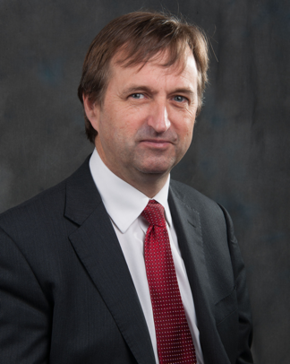
Michael Cadier was educated at the French Lycée in London, studied at Oxford University and undertook Medicine at St Thomas’ Hospital, London. After training in London, Salisbury and Bristol he became an NHS Consultant in the Supra-regional Plastic Surgery Unit in Salisbury in 1996, becoming Head of this Service in 1999. In his NHS practice he developed a breast reconstruction service in Portsmouth, and in 2000 was appointed as cleft surgeon to the newly established Spires Cleft Centre, for which he also became the first Clinical Director in 2002. He undertook yearly cleft lip and palate Charity missions in rural Pakistan from 1996 to 2009. He has a busy aesthetic surgery private practice along the South Coast, undertaking the full range of aesthetic surgery procedures. He has performed over a thousand facelifts, and over 1500 breast augmentations, with similar numbers for all of the more common aesthetic procedures. In 2015 he became fully private, concentrating solely on aesthetic surgical practice.

He is widely published and lectures and teaches on aesthetic surgery both nationally and internationally. In 2006 he was invited to become an examiner for the FRCS (Plast). He is the Program Director for the South Coast Reconstructive Cosmetic Surgery Fellowship, was part of the first UK delegation in the CEN in cosmetic surgery (European regulation) and chaired the CSIC Royal College committee on Clinical Quality and Outcomes in Cosmetic Surgery.

The British Association of Aesthetic Surgeons (BAAPS) is the leading organization for aesthetic surgery in the UK. He was elected to BAAPS Council in 2006 and was President of BAAPS from 2014 to 2016. One of his key objectives is to ensure that UK plastic surgeons of the future will practice aesthetic surgery to the highest possible standard and with that aim he has helped establish a comprehensive national training program in aesthetic surgery.

