Mr Michael Cadier

BA MA (Oxon) MBBS (London) MS (Soton), FRCSEd, FRCS (Plast) President of BAAPS 2014-2016
Consultant in Plastic, Reconstructive & Aesthetic Surgery

Abdominal recontouring

Abdominal recontouring - General Information.

The ideal abdominal profile is smooth with no excess skin and no bulging. In women ideally there is a very slight concavity above the belly button and a slight convexity below the belly button with a midline indentation running top to bottom. In males the ideal abdominal contour is frequently said to be the six-pack. With age, changes in weight, alterations in muscle tone and in women pregnancies, the abdominal contour may be altered and result in an undesirable appearance. A variety of procedures are available for abdominal re-contouring.

What is an abdominoplasty?

This operation aims to reduce the bulging of the abdomen (and correct any overhang), this being caused by excess skin and fat, and made worse by either a split in or weakness of the abdominal musculature. At surgery a large ellipse of skin and fat from the lower abdomen is excised leaving a scar as best placed within the bikini line. The belly button is often re-sited and there may therefore be a scar around the belly button, though in most cases this is inconspicuous. Not infrequently liposuction is undertaken to remove fat excess from the front and sides of the abdomen. A repair of any split in the muscle may also be performed. The procedure takes about 2-2½ hours to perform, and usually requires a general anaesthetic and a two night stay in hospital post-operatively. The lower wound is sutured in a multilayered

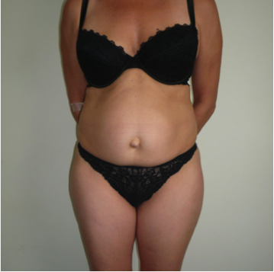
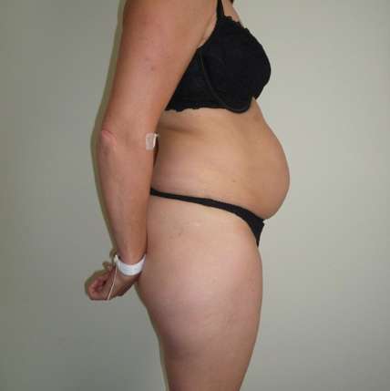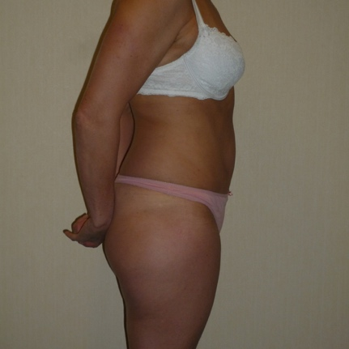
Pre and 5 months post op in patient there is a significant muscle split (rectus divarication)

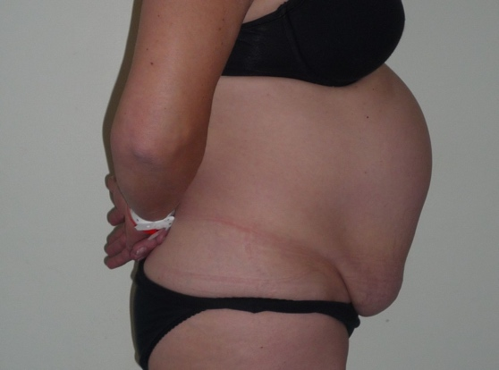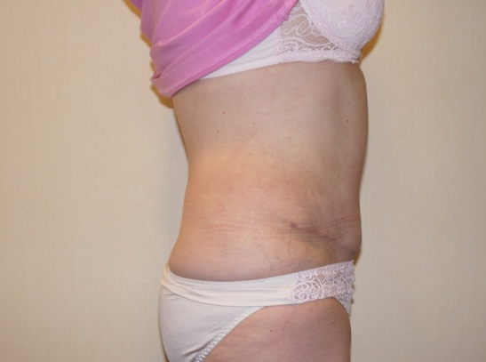
Pre and 5 months post op in patient with both skin excess and a muscle spilt

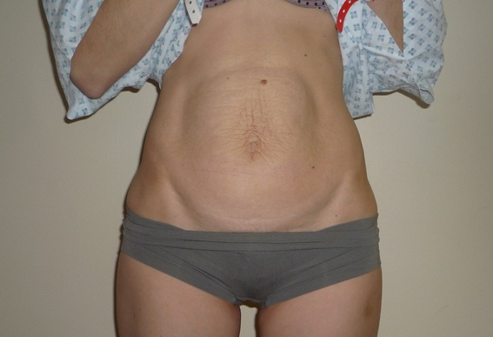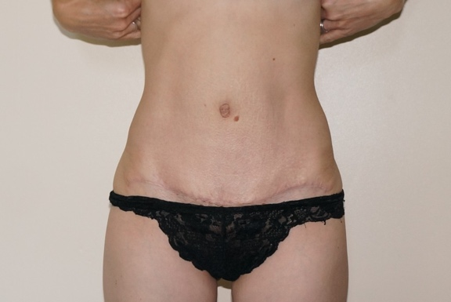
Pre and 5 months post op in patient with both skin excess and a muscle spilt

fashion to enable contouring and to reduce tension of the skin edges. All of the sutures are self-dissolving. The abdominoplasty is by far the commonest surgical procedure undertaken for abdominal re-contouring and is frequently termed a tummy tuck. The procedure has a very high patient satisfaction rating and excellent results can be achieved.

What other procedures are available?

Although the routine abdominoplasty is by far the commonest procedure undertaken, a variety of other procedures can be performed in particular cases.

When there is minimal to no skin excess or in patients that do not wish for any scarring abdominal liposuction may be an appropriate procedure.

In patients with very minor skin excess, usually associated with an indented C-section scar, a mini-abdominoplasty may be recommended.

In patients with high belly buttons and where the skin excess is not marked an umbilical slide abdominoplasty may be performed.

If skin laxity extends around the sides an extended abdominoplasty can be performed where skin at the sides is also excised.

If skin laxity extends around the sides and back a circumferential abdominoplasty can be performed where skin above the buttocks is also excised.

In patients with very large abdominal aprons, or in those where massive weight loss has occurred an apronectomy or massive abdominoplasty may be the technique of choice.

In patients who have had massive weight loss excision of a vertical skin ellipse can be added to the standard lower transverse ellipse, occasionally with an additional transverse ellipse under the breast (or chest – in males) – these are termed Fleur de Lys abdominoplasties, and Extended Fleur de Lys abdominoplasties, respectively.

Very occasionally a reverse abdominoplasty can be undertaken where the transverse skin ellipse that is excised is situated in the upper part of the abdomen.

Some of these alternative procedures are described in the following sections. The rest of this information sheet relates to the normal abdominoplasty procedure.

Abdominal liposuction.

Abdominal liposuction alone is a reasonably straightforward procedure, which leaves a few usually inconspicuous scars, is relatively low in risk and recovery is usually rapid. However, the effect of abdominal liposuction alone will be limited if there is any skin excess or if the skin tone is poor or if there is significant muscle laxity causing abdominal bulging. If these problems are present then the effect may be limited and in certain cases liposuction may be detrimental and result in an uneven abdominal contour. Although techniques of ultrasound and laser assisted liposuction have over the years been proposed as means of skin tightening the effect is limited and there is a potential risk of damage to the skin, which may lead to scarring or skin loss. The rest of this information sheet is not relevant to abdominal liposuction alone. Further details can be found in the Liposuction information sheet.

Mini abdominoplasty.

When there is a small excess of skin in the lower abdomen (this may be associated with a scar from a Caesarean section) then a mini abdominoplasty may be appropriate. In this procedure skin and fat is excised from the lower abdomen leaving a scar in the bikini line of relatively limited length. When there is fat excess liposuction may be added and when there is muscle laxity a repair of the muscle situated beneath the belly button may be undertaken. The operation is quicker than a full abdominoplasty and usually takes one to one and half hours to perform either under local or general anaesthetic.

The effect is however limited and, in many cases will not provide an adequate correction of the abdominal contour. The rest of this information sheet applies in general however with this variation the recovery is faster and potential risks fewer.

Apronectomy/massive abdominoplasty.

This operation is usually reserved for patients who have a massive abdominal overhang usually resulting from excessive weight changes. This operation aims to remove the overhang of skin and fat and leaves a long scar, which may extend around the lower half of the body in the bikini line. This operation may take anywhere from two to three hours to perform. The rest of this information sheet applies in general, however the recovery is frequently more prolonged and the potential for complications is much higher – in particular wound healing issues, with an increased potential for infections that may necessitate prolonged periods of dressings.

Fleur de Lys and Extended Fleur de Lys Abdominoplasties

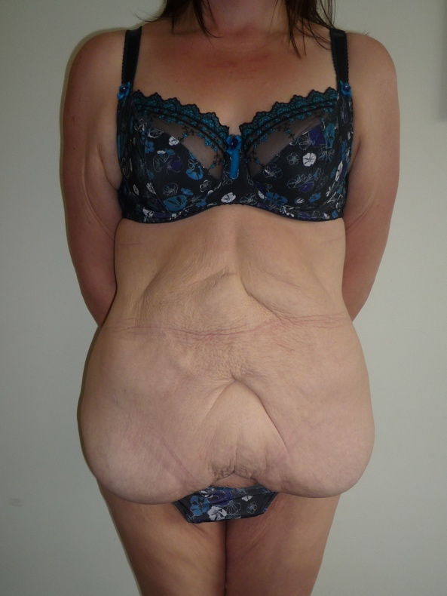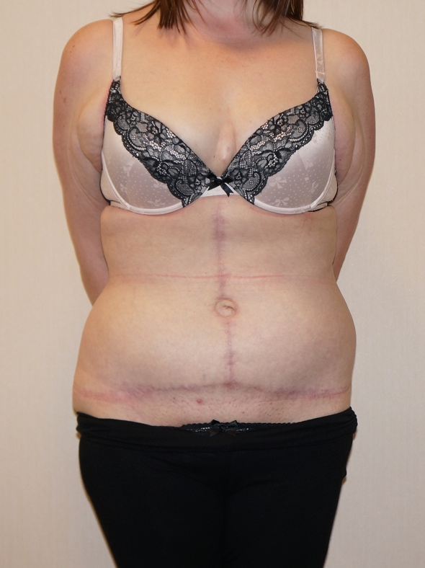

Pre and 6 month post-operative photographs following Fleur de Lys abdominoplasty

These procedures are almost always performed in those patients that have had massive weight loss – not infrequently following bariatric surgery. The skin laxity is not just in the up/down direction but also from side to side. Additional rolls of tissue may occur above the belly button. A vertical ellipse of skin is added to the lower transverse excision and when rolls of tissue occur above the belly button an additional transverse ellipse below the breast or chest can be added. Again, these procedures are associated with a far more prolonged recovery, and the potential for complications is much higher – in particular wound healing issues, with an increased potential for infections that may necessitate prolonged periods of dressings. These problems particularly apply around the T-junctions. With these procedures a very clear awareness as to realistic outcomes needs to be appreciated as many patients will still have remnant skin excess and bulges in other areas, that may benefit from additional surgical procedures at a later date, which will incur additional fees.

Pre-operative advice.

In order to optimize the result and minimize the risks a number of factors should be considered. Smokers have a much higher risk of developing complications. It is therefore advised that they should refrain from smoking for ideally four weeks prior to, and four weeks following surgery. Aspirin and related anti-inflammatories (other than those prescribed during the admission) should be avoided for one week before and 48 hours after surgery as these can significantly increase the risk of bleeding. Many supplements (gingko, ginger, turmeric, garlic) have anti-coagulant effects and therefore can increase the risk of bleeding and bruising and should be discontinued for a similar time period. The use of arnica is debatable with no clear evidence to support either its use or its avoidance.

It is recommended that patients on the combined oral contraceptive, and hormone replacement therapy, should stop these for four weeks prior to, and four weeks after surgery, as they may be associated with an increased risk of deep vein thrombosis (DVT). For patients on the pill alternative forms of contraception should be used.

Patients who are overweight also have a higher risk of complications, and abdominoplasties should not be seen as a way of losing weight. If patients are dieting, they should aim to get to their desired weight pre-operatively. Mr Cadier and his team have the policy that such surgery will only be offered to patients with a Body Mass Index (BMI) of less than 36. The BMI is calculated from the weight and height, and there are many simple tools available on the internet to help perform this calculation. Patients with a BMI of 36 or over have much higher risks both from the surgery and the anaesthetic and the risks therefore potentially outweigh the benefits.

What happens before the operation?

At the initial consultation with Mr Cadier after discussing regarding the specific concerns a full medical and surgical history will be obtained. As part of the consultation a psychological assessment is made to ensure that it is appropriate to undertake the surgery, and on occasions the completion of a psychological questionnaire may be required. In all cases Mr Cadier will write to the GP to request a past medical history. Patients may refuse this but need to be aware they are exposing themselves to more risks should they omit or forget some relevant past medical history. Also, in the post-operative period should there be any problems it is important that the GP is aware what has been undertaken in order to be able to offer effective help and advice. At the consultation details regarding the operation, the aims, the limitations, the recovery and the risks will be discussed. Before the operation you will usually attend for a pre-operative nurse led assessment. You may require a blood test. Any significant health problems not previously identified may be discussed with Mr Cadier or the anaesthetist, and a further assessment may be required to determine suitability for the procedure.

At admission you will again be assessed by the nurses and you will be measured for a pair of compression stockings. These are worn to reduce the risk of thrombosis formation and should be worn for a minimum two weeks post-operatively. You will be seen by the anaesthetist prior to surgery and be able to discuss issues pertaining to the anaesthetic and also pain relief in the immediate post-operative period. You will also see Mr Cadier who may make some pre-operative markings and will take photographs for the medical records.

What to expect immediately after the operation

On return to the ward you will be nursed with your knees flexed, either on your side or on your back. Pillows are usually placed under your knees for support. This is to prevent tension on your stitch lines. Suction drains are used to help reduce fluid accumulation under the skin. Your blood pressure and pulse will be taken regularly following your return to the ward. You will have an intravenous infusion (a drip), which is usually removed after 24 hours once you are able to tolerate diet and fluids comfortably. If you experience any pain or discomfort following surgery painkillers are given either by injection or as tablets. These will enable you to breathe and move more comfortably. It is important because of your flexed position that you do take regular deep breaths and move your feet regularly to promote your circulation.

The day after surgery you will be encouraged to gradually increase your mobility. At first, when walking, try to stay slightly bent. Assistance will be given with hygiene until you are able to manage independently. Following removal of your drains (usually on the second day post-op) you will be advised to rest in bed.

At the end of the operation you will usually have been fitted with a pressure garment. This helps to provide support, especially if there has been a muscle repair, and also helps in the moulding process, especially when liposuction has been undertaken. You will be advised to wear this pressure garment for six weeks post-operatively.

What to expect after discharge.

Your length of stay in hospital is variable and depends on many factors but is usually 2 days. Following the abdominoplasty procedure dressings are applied in the operating theatre as follows: butterfly tapes are applied directly to the wound and then a waterproof absorbent dressing is placed over this. These dressings are usually left intact for seven days following surgery unless they become messy, in which case they are changed prior to discharge. Patients are invited to re-attend at seven and fourteen days post discharge for wound checks by the nursing staff and a change of dressings. Dressings are usually required for a total of about two to three weeks following surgery. The tapes that are applied directly to the wound should be left longer if possible. From two to four weeks postoperatively (once the tapes have dropped off) the wound should be massaged once or twice a day with Vitamin E containing cream or lotion.

The wound should be kept dry whilst the dressings are in place and during this period of time patients are advised to wash around the area with a flannel. With the waterproof dressing patients can shower however, these should be brief and as best possible the dressing should be kept away from the water. After this period the patients can get the wound wet provided there are no significant wound problems. Prolonged soaking in a bath should be avoided for at least three weeks postoperatively.

Although the drains are usually removed before discharge, occasionally one drain is left in for an extra few days. You will then be asked to return to the hospital for removal of the drain. Occasionally following removal of the drains fluid accumulates under the skin. This is called a seroma and may require aspiration in the outpatients on several occasions.

Some numbness around the lower abdomen is inevitable following the surgery. Although it will improve over time some permanent numbness around the scar will persist.

Some bruising and some swelling are also inevitable. These increases with the magnitude of the procedure and are more pronounced when liposuction has been performed. The bruising usually resolves after 1-3 weeks, but the swelling may persist for 1-3 months and in some cases may persist longer. Using a pressure garment for a longer period is very occasionally required.

Patients will find that because of the abdominal tightness they will need to pass water more frequently for the first few days following surgery. Some patients experience a degree of constipation. This latter can be helped by early mobilization, avoiding excessive amount of codeine containing medication and increasing the fibre content of the diet. However, heavy meals should be avoided in the first two to three weeks following surgery, as they will cause abdominal discomfort.

At discharge a letter will normally be sent from the ward to your General Practitioner informing them of your admission and of the procedure undertaken. Patients are encouraged to keep their GPs informed however should they wish the admission to remain confidential please inform the ward staff and no communications will be sent.

What restrictions are their following surgery?

For the first two weeks following surgery patients should rest and convalesce. They should refrain from driving or from undertaking any light housework. After this two-week period light housework and gentle activities can be undertaken, gradually building up over a six to eight week period. However, heavy lifting or any vigorous sporting activities (aerobics, tennis, and badminton) should be avoided for two to three months following surgery. Most patients refrain from work for two weeks, however in those with physical jobs or whom recovery is delayed an additional 1-2 weeks may be required. Sexual activities can resume when patients feel comfortable but usually no earlier than two weeks following surgery. Abdominoplasties are usually undertaken when the family is complete if, however, circumstances change, pregnancy should be avoided for at least six months and preferably twelve months following surgery.

What about pain relief?

The abdominoplasty procedure can be quite painful and uncomfortable especially with the plication of the muscles. This is most marked centrally under the rib cage. Regular pain relief is advised for the minimum of at least one week following surgery (usually a combination of anti-inflammatory medication and Paracetamol or Paracetamol / Codeine mixes). These should be prescribed prior to discharge from the hospital. Following the initial week pain relief should be taken as required. Some patients experience cramp like pains several weeks post-operatively. This is normal and may be due to muscle spasms with the return to normal activities. It will usually settle spontaneously.

Sleeping and posture.

Most patients experience significant tightness in the abdomen resulting in an inability to straighten up. This will gradually resolve over the first one to three weeks following surgery however patients are encouraged to try to straighten up fully after a few days (the wound will not pop open!). Some patients experience lower back pain as a result of this poor posture. Inadvertently straightening up will cause discomfort but should not damage any of the stitches or the wound. As a result of this inability to straighten up and also because lying the side is frequently painful (especially if liposuction has been undertaken) patients may need to sleep on their backs slightly propped up for ten to fourteen days following surgery. Some patients find this very disturbing from a sleep point of view and should this be the case then a short course of sleeping tablets may be required.

Clothing and underwear.

Initially there is significant swelling which may take between six and eight weeks to resolve (patients frequently notice a generalized fluid retention and notice their weight has actually increased for several weeks following surgery). Many patients find that their clothes feel too tight and therefore looser clothing is required. Tight clothing and especially tight underwear that pinches and causes an indentation should be avoided for several weeks following surgery as this may interfere with the aesthetic result especially if liposuction has been undertaken. This is because the indentation will induce moulding of the fat and may leave a permanent contour defect.

Limitations, realistic expectations and lifestyle.

Abdominoplasties are associated with very high rates of patient satisfaction. However, patients do need to be realistic and aware of the limitations. In particular in an overweight or unfit patient visceral fat or weak abdominal muscles may lead to residual bulging and patients will need to develop a healthy lifestyle through diet and exercise to optimize the result. The abdominoplasty has a limited effect on the flank and “love handles”. Where this is a concern supplementary maneuvers such as flank liposuction or an extended abdominoplasty or even lower body lift may be required. Losing weight after an abdominoplasty does not usually cause any aesthetic problems and in most enhances the result. Gaining weight however may cause problems of generalized bulging and in particular can lead to the development of a bulge or ridge above the scar. If this occurs patients are encouraged to diet and exercise as whilst further surgical correction is always possible these will incur additional costs.

What are the risks?

The risks include:

- Seroma – fluid accumulation 1-10%
- Chronic seroma - rare
- Infection – 1-5%
- Severe infection resulting in necrotizing fasciitis – very rare
- Skin necrosis – uncommon – less than 1%
- Haematoma – uncommon – less than 1%
- Poor scarring including hypertrophic and keloid scarring
- Recurrent scar problems as a result of ingrowing hairs (more common in men)
- Suture or dissolving staple extrusion
- Fat necrosis
- Contour anomalies – including dog ears
- Loss of the bellybutton – very rare
- Numbness down the thigh (lateral cutaneous nerve problem)
- Persistent pain (neuropathic/causalgia)
- Rupture of the rectus muscle repair
- Damage to the bowel or internal organs

- Deep vein thrombosis and life-threatening pulmonary embolism
- Anaesthetic complications – these will be discussed with you by the anaesthetist before surgery.
- Death

Seromas occur when fluid accumulates beneath the skin. Usually the drains will remove any oozing and after removal the body will absorb any remnant ooze. However, on occasions fluid does accumulate and at 10-14 days post-operatively the lower abdomen becomes swollen and patients will feel fluid moving around. Mr Cadier will need to drain the seroma by aspirating in clinic (this is a painless procedure that takes a few minutes). It will probably need to be repeated weekly for several weeks. Very rarely if it fails to settle additional surgery may be required.

The commonest complication is wound infection. Occasionally antibiotics are required, and dressing may be required for a longer period. In severe infections wounds can breakdown, usually in the middle of the bikini line scar. This is a very unusual complication in non-smokers and patients of normal body weight. Patients who do smoke should refrain for 4 weeks before and at least 4 weeks after surgery. Usually the wounds will heal with simple dressings alone, though occasionally secondary surgery may be required. In very severe infections the tissues can be damaged and skin loss can occur. Secondary surgery will almost certainly be required; very rarely this involves the use of skin grafts.

An accumulation of blood under the skin can develop either within the first 1-2 days following surgery or rarely after drain removal. The abdomen becomes swollen and severely bruised. A return to the operating theatre for drainage is required in most cases.

There will be a scar. The location and extent will be discussed pre-operatively. In most cases it is concealed beneath the bikini line, with a small scar around the belly button. The scar is not usually visible when wearing bikinis or normal underwear. By careful suture technique and using a multilayered closure a very good scar usually results. However full scar maturation may take months or even 1-2 years. Some patients may develop a raised and stretched red scar (a hypertrophic or keloid scar) and in some cases additional measures including silicone therapy, and steroid injections may be required. Scar problems are more common in areas of hair bearing skin – in the pubic hairline (or in the whole scar in men). The hairs will cause irritation as they grow through the scar. This usually resolves by itself after 2-3 months. Similarly sutures and plastic staples may extrude through the scar causing irritation. All of the sutures and staples are dissolving though this may take several months.

In some cases, patients will fell hard lumps under the skin – usually above the pubic area. They can sometimes be uncomfortable. These may be areas of fat necrosis – a small amount of fat dies leading to a local inflammation. It is more common when liposuction has been done. Unless it leaves a visible lump is it best left as it will usually gradually dissipate though this can take many months.

Contour anomalies may occur, especially in patients who are more overweight. On occasions a second procedure (usually under local anaesthetic) is required to correct these problems, though usually only several months later.

Loss of the bellybutton is very rare, and usually only occurs if there is an associated hernia in the bellybutton or scarring from previous surgery.

Where the incision goes across at the sides of the pubic area above the thighs nerves that supply the skin sensation to the front or sides of the upper thigh can be damaged or compressed in scar tissue. This can lead to patches of numbness or pain in the scar or down the thigh. If patients experience long term pain additional treatment may be required.

With all surgical procedures including abdominal contouring a small group of patients experience long term nerve related pain known as causalgia. Why this occurs in some people is not understood. Although eventually it will fade away sometimes medication is required to try to speed up its resolution.

If patients experience a severe coughing or vomiting bout in the early stages following surgery the muscle repair can potentially split. However. It is sutured in such a way as to keep this risk to a minimum and muscle repair failure is extremely rare.

Damage to the bowel or internal organs is an extremely rare complication that usually results from liposuction in an abdomen with previous surgical scars or when hernias are present. Where appropriate this will be discussed at the initial consultation.

Following any surgery there is a risk in developing a deep vein thrombosis (DVT). This is a clot in the calf vein of the leg. In itself it may result in pain and swelling. The risk is that should the clot separate from the vein it can move to the lungs resulting in a pulmonary embolism. This is a potentially life-threatening situation. All attempts are made to reduce the risk using compression stockings during and for two weeks after surgery, using pneumatic compression devices on the legs at surgery and in the immediate post-operative period, by encouraging early mobilization, advising patients to stop the combined oral contraceptive pill or Hormone Replacement Therapy (HRT) four weeks prior to surgery, and where it is felt appropriate using injections of blood thinning agents.

All surgical and anaesthetic procedures have risks and some are life threatening, these include pulmonary embolism, anaphylaxis (severe allergic response to a medication) and adverse drug reactions. Death however remains an extremely rare complication.

When complications do occur, all attempts are made not only to remedy the problem in as speedy a manner as possible but also to optimise the final result. As with all cosmetic surgical procedures undertaken by Mr Cadier, there is a fixed fee policy, which means that no further charges are incurred for the treatment of complications that are identified within 6 months following the initial surgery. Revisional policies for aesthetic concerns have changed and, in most cases, additional fees will be incurred. Patients need to be aware regarding the limitations of surgery and have very realistic expectations about outcomes.

Most patients are however delighted with the result of surgery. In many it will restore them back to their pre-pregnancy or even teenage abdomen. This enables patients to wear clothing that they will not have been able to wear for many years because of the embarrassment of their bulging abdomens. Specially designed compression underwear will be a thing of the past. Many patients experience a huge boost in their self-confidence and self-esteem and abdominoplasties are associated with very high patient satisfaction rates.

Contact details:

Private Office:

Address: 36 Batten Road, Downton, Salisbury, SP5 3HU
PA: Nicola Haicalis
Ph: 01725 511 550
Fx: 01725 511 846
Email: nicola.haicalis@michaelcadier.com

Website : www.michaelcadier.com

Hospitals :

Nuffield Bournemouth, 67 Lansdowne Rd, Bournemouth Dorset, BH1 1RW.
Tel: 01202 291866

About your Surgeon:

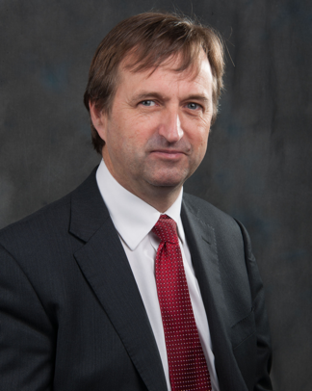
Michael Cadier was educated at the French Lycée in London, studied at Oxford University and undertook Medicine at St Thomas’ Hospital, London. After training in London, Salisbury and Bristol he became an NHS Consultant in the Supra-regional Plastic Surgery Unit in Salisbury in 1996, becoming Head of this Service in 1999. In his NHS practice he developed a breast reconstruction service in Portsmouth, and in 2000 was appointed as cleft surgeon to the newly established Spires Cleft Centre, for which he also became the first Clinical Director in 2002. He undertook yearly cleft lip and palate Charity missions in rural Pakistan from 1996 to 2009. He has a busy aesthetic surgery private practice along the South Coast, undertaking the full range of aesthetic surgery procedures. He has performed over a thousand facelifts, and over 1500 breast augmentations, with similar numbers for all of the more common aesthetic procedures. In 2015 he became fully private, concentrating solely on aesthetic surgical practice.

He is widely published and lectures and teaches on aesthetic surgery both nationally and internationally. In 2006 he was invited to become an examiner for the FRCS (Plast). He is the Program Director for the South Coast Reconstructive Cosmetic Surgery Fellowship, was part of the first UK delegation in the CEN in cosmetic surgery (European regulation) and chaired the CSIC Royal College committee on Clinical Quality and Outcomes in Cosmetic Surgery.

The British Association of Aesthetic Surgeons (BAAPS) is the leading organization for aesthetic surgery in the UK. He was elected to BAAPS Council in 2006 and was President of BAAPS from 2014 to 2016. One of his key objectives is to ensure that UK plastic surgeons of the future will practice aesthetic surgery to the highest possible and with that aim he has helped establish a comprehensive national training program in aesthetic surgery.

