Mr Michael Cadier

BA MA (Oxon) MBBS (London) MS (Soton), FRCSEd, FRCS (Plast) President of BAAPS 2014-2016
Consultant in Plastic, Reconstructive & Aesthetic Surgery

The Supraciliary (Direct) Brow Lift
The Eyebrow

The eyebrow is very important in facial expression. A lowered brow may give the impression of being tired or cross, whilst an elevated brow can give a surprised or startled look. With ageing, the brow tends to become lowered and the brow lift aims to correct this. Usually the outer aspect drops more, which can result in a sad look. This brow droop (ptosis) is often accompanied by increased frown lines across the forehead and between the eyebrows as patients unconsciously elevate their eyebrows using the forehead muscles. The brow lift procedure aims to correct these changes by elevating the eyebrows. Several techniques are available, depending on patient preference and what is required – this information sheet describes only the supraciliary or direct brow lift. A separate information sheet is available for the other techniques including foreheadplasty, endobrow and bicoronal techniques.

The eyebrow shape and position vary hugely between patients. The aesthetic ideal is considered to be a flat eyebrow in males that sits on the eyebrow ridge, and in females an arched brow that sits slightly higher than the eyebrow ridge. However, these ideals should be treated with caution as they may not be appropriate for individual patients. Another consideration is that patients frequently present with what they feel is upper eyelid skin excess, but which actually turns out to be eyebrow droop. In many cases it is a combination of both upper eyelid excess and eyebrow droop. During the consultation this will be identified, and appropriate treatments suggested. Finally, it should be noted that in some cases surgery may not be the best option and that treatment with botulinum toxin and/or dermal fillers may be preferable. When appropriate, this will be discussed at the initial consultation.

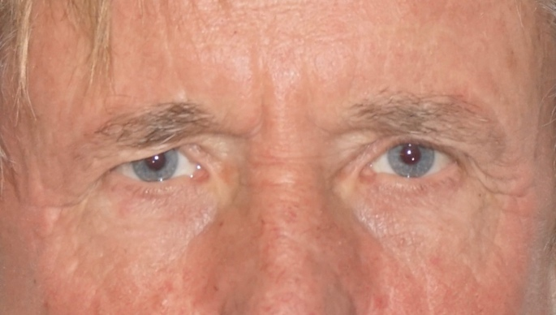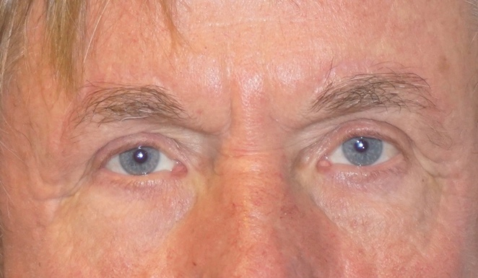
Photographs of patient pre and 5 months post operatively

The supraciliary brow lift.

With the supraciliary brow lift the aim of surgery is to reproduce the ideal shape and contour by removing excess skin above the eyebrow. The surgery is usually undertaken under local anaesthetic and when undertaken alone is performed in the minor operating department without the need for hospital admission. It usually takes about 1 hour to perform. Any deeper sutures are usually self-dissolving and the skin edges are usually approximated with a fine single suture. This minimizes the risk of conspicuous scarring.

Pre-operative advice.

In order to optimize the result and minimize the risks a number of factors should be considered. Smokers have a much higher risk of developing complications. It is therefore advised that they should refrain from smoking for ideally four weeks prior to, and four weeks following surgery. Aspirin and related anti-inflammatories (other than those prescribed during the admission) should be avoided for one week before and 48 hours after surgery as these can significantly increase the risk of bleeding. Many supplements (gingko, ginger, turmeric, garlic) have anti-coagulant effects and therefore can increase the risk of bleeding and bruising and should be discontinued for a similar time period. The use of arnica is debatable with no clear evidence to support either its use or its avoidance.

The use of Botulinum toxin should be avoided before surgery as it can interfere with the eyebrow position. This makes it very difficult to determine the amount of skin that needs to be removed. Patients should therefore avoid Botulinum treatment for 3-6 months prior to surgery. They can have this treatment again 2-3 weeks following surgery.

When patients are having a general anaesthetic, it is recommended that patients on the combined oral contraceptive, and hormone replacement therapy, should stop these for four weeks prior to, and four weeks after surgery, as they may be associated with an increased risk of deep vein thrombosis (DVT). For patients on the pill alternative forms of contraception should be used. Likewise, patients who are overweight also have a higher risk of complications. If patients are dieting, they should aim to get to their desired weight pre-operatively. Mr Cadier and his team have the policy that such surgery will only be offered to patients with a Body Mass Index (BMI) of less than 36. The BMI is calculated from the weight and height, and there are many simple tools available on the internet to help perform this calculation. Patients with a BMI of 36 or over have much higher risks both from the surgery and the anaesthetic and the risks therefore potentially outweigh the benefits.

What happens before the operation?

At the initial consultation with Mr Cadier after discussing regarding the specific concerns a full medical and surgical history will be obtained. As part of the consultation a psychological assessment is made to ensure that it is appropriate to undertake the surgery, and on occasions the completion of a psychological questionnaire may be required. In all cases Mr Cadier will write to the GP to request a past medical history. Patients may refuse this but need to be aware they are exposing themselves to more risks should they omit or forget some relevant past medical history. Also, in the post-operative period should there be any problems it is important that the GP is aware what has been undertaken in order to be able to offer effective help and advice. At the consultation details regarding the operation, the aims, the limitations, the recovery and the risks will be discussed.

In patients having the procedure performed under a general anaesthetic before the operation you will usually attend for a pre-operative nurse led assessment. You may require a blood test. Any significant health problems not previously identified may be discussed with Mr Cadier or the anaesthetist, and a further assessment may be required to determine suitability for the procedure. At admission you will again be assessed by the nurses and you will be measured for a pair of compression stockings. These are worn to reduce the risk of thrombosis formation and should be worn for a minimum two weeks post-operatively. You will be seen by the anaesthetist prior to surgery and be able to discuss issues pertaining to the anaesthetic and also pain relief in the immediate post-operative period.

With eyebrow corrections careful assessment of the upper eyelid is also required to ensure that patients receive the appropriate treatment. At admission you will again be assessed by the nurses and seen by Mr Cadier who will take preoperative photographs, obtain written consent for the procedure and draw out the planned excision with the patient standing in front of a mirror.

What to expect immediately after the operation.

Antibiotic ointment may be applied to the suture lines. This reduces the risk of infection and is said to promote better healing. Although you will be free to leave very shortly after surgery, under local anaesthesia patients are encouraged to sit quietly for 30 minutes prior to leaving the hospital. If under general anaesthetic patients will need to stay for 2-4 hours prior to discharge.

What to expect after discharge.

The degree of swelling and bruising in the eyebrows is usually very mild however, when present may persist for one to three weeks. The hideaway period is usually 7-10 days. If swelling is present patients are advised to use extra pillows and to keep themselves propped up at night for several days following surgery. Initially the eyebrows will feel tight and especially if other facial procedures have been undertaken. The tightness will resolve spontaneously though this may take several days. The eyebrows do need to be slightly over elevated as some descent over time is inevitable. This settling down may take several weeks. Patients usually notice some numbness in the upper eyelid region following surgery, again this will resolve spontaneously but may take several months to fully correct. The sutures will be conspicuous until removal at 7-10 days post operatively. After suture removal the scar will stay red for several weeks and may be raised or indented, depending on the degree of swelling. This will all gradually settle down and the scar will fade and usually become very inconspicuous. How long this take is extremely variable and ranges from weeks to months. Makeup can be applied after 10 days.

Pain relief.

Eyebrow corrections are not normally associated with significant pain but should there be any pain simple analgesics such as Paracetamol may be used. Aspirin, Ibuprofen and other non-steroidal anti-inflammatories (unless specifically prescribed) should be avoided for the first 24 hours as they may increase bruising.

Wound care and washing.

Patients will be given an antibiotic ointment to apply three times a day sparingly to the wound, until suture removal. Ideally the area should be kept dry but hair washing, and showering can be undertaken within 24 hours. If the wounds get wet, they should be dabbed dry and not rubbed.

Restrictions and activities.

Patients are advised not to drive for 1-2 days following surgery. Activities should be reduced for the first three to four weeks following surgery.

Follow up.

Patients will be reviewed for removal of sutures and wound checks by the nursing staff in the outpatient department 7-10 days following surgery. Patients will be reviewed by Mr Cadier at a minimum of one and five months postoperatively in the outpatients. Appointments for the wound check and suture removal will be given prior to discharge and appointments to see Mr Cadier in the outpatients will be sent via the post.

Risks and complications.

As with all surgical procedures complications may occur however these are uncommon in eyebrow corrections. Early identification and prompt are important, and should patients have any cause for concern they should either contact the hospital or Mr Cadiers’ secretary.

The risks include:

- Bleeding
- Severe bruising
- Haematoma
- Infection
- Wound breakdown
- Drying of eyes
- Poor scarring including stretched, indented, hypertrophic and keloid scars
- Asymmetry
- Recurrence of the eyebrow droop

If under general anaesthetic the following also apply:

- Deep vein thrombosis and life-threatening pulmonary embolism
- Anaesthetic complications – these will be discussed with you by the anaesthetist before surgery.
- Death

Initially there may be some bleeding or oozing from the wound edge. This is normal. Some bruising is inevitable and occasionally it is marked. A collection of blood requiring surgical removal (a haematoma) is extremely rare. Swelling is again inevitable and usually will have settled down to an acceptable degree within 1-2 weeks. Occasionally it is more prolonged. Occasionally the wound edge may gape. Mostly this self corrects with no adverse effect. Sometimes the wound requires a tape to be applied and very rarely an additional suture.

Temporary drying of the eyes is not uncommon for the first 1-3 weeks and is due to a transient disturbance of the blink mechanism. Artificial tears may be necessary. In some patients drying of the eyes is associated with a gritty feeling, in others excessive tearing may result. Infections can occur in any surgical wound but in eyebrow corrections this is extremely rare. Should it occur either topical or oral antibiotics may be necessary.

The scars following eyebrow corrections in most cases become very inconspicuous however, scar maturation may take several months. In patients with pale skin and pale eyebrows the scars may remain red for a prolonged time. In women the application of eyebrow pencil or even eyebrow tattooing, or micro-blading may help conceal the scar. Rarely the scar becomes raised and red in a process known as hypertrophic scarring, or in worse cases keloid scarring. Should this occur additional measures such as vigorous massaging, silicone gel application or steroid injections may be required. Occasionally the scar becomes indented – this usually settles over time with gentle massage.

Some asymmetry in the eyebrow position is normal although all attempts are made to ensure good symmetry. Patients may notice their eyebrows elevate differently – this is absolutely normal, and surgery does not change this.

Some recurrence of eyebrow droop will always occur therefore the eyebrows are usually placed a little bit higher to compensate for this. If some patients – especially in older patients or those with stretchy skin the recurrence is marked.

When undertaken under general anaesthetic with any surgery there is a risk in developing a deep vein thrombosis (DVT). This is a clot in the calf vein of the leg. In itself it may result in pain and swelling. The risk is that should the clot separate from the vein it can move to the lungs resulting in a pulmonary embolism. This is a potentially life-threatening situation. All attempts are made to reduce the risk using compression stockings during and for one to two weeks after surgery, using pneumatic compression devices on the legs at surgery and in the immediate post-operative period, by encouraging early mobilization, advising patients to stop the combined oral contraceptive pill or Hormone Replacement Therapy (HRT) four weeks prior to surgery, and where it is felt appropriate using injections of blood thinning agents.

All surgical and anaesthetic procedures have risks, and some are life threatening, these include pulmonary embolism, anaphylaxis (severe allergic response to a medication) and adverse drug reactions. Death however remains an extremely rare complication.

Risks and complications will be discussed, and all efforts made to minimize any risks. Patient safety is always our first concern.

When complications do occur, all attempts are made not only to remedy the problem in as speedy a manner as possible but also to optimise the final result. As with all cosmetic surgical procedures undertaken by Mr Cadier, there is a fixed fee policy, which means that no further charges are incurred for the treatment of complications that are identified within 6 months following the initial surgery. Revisional policies for aesthetic concerns have changed and, in most cases, additional fees will be incurred. Patients need to be aware regarding the limitations of surgery and have very realistic expectations about outcomes.

Most patients are delighted with the result of surgery. The main effect is to brighten up the eyes and to reduce the tired and sad look associated with this problem. A generalised rejuvenating effect is often also achieved. The eyebrow correction is usually very long lasting, and most patients seldom require any further surgery.

Contact details:

Private Office:

Address: 36 Batten Road, Downton, Salisbury, SP5 3HU
PA: Nicola Haicalis
Ph: 01725 511 550
Fx: 01725 511 846
Email: nicola.haicalis@michaelcadier.com

Website : www.michaelcadier.com

Hospitals :

Nuffield Bournemouth, 67 Lansdowne Rd, Bournemouth Dorset, BH1 1RW.
Tel: 01202 291866

Spire Southampton Hospital, Chalybeate Close, Southampton, Hampshire, S016 6UY.
Tel : 02380 775544

About your Surgeon:

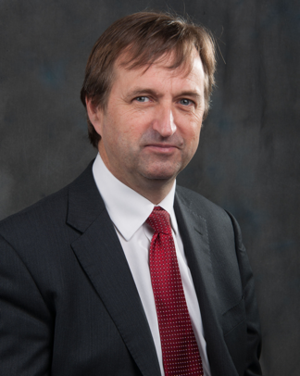
Michael Cadier was educated at the French Lycée in London, studied at Oxford University and undertook Medicine at St Thomas’ Hospital, London. After training in London, Salisbury and Bristol he became an NHS Consultant in the Supra-regional Plastic Surgery Unit in Salisbury in 1996, becoming Head of this Service in 1999. In his NHS practice he developed a breast reconstruction service in Portsmouth, and in 2000 was appointed as cleft surgeon to the newly established Spires Cleft Centre, for which he also became the first Clinical Director in 2002. He undertook yearly cleft lip and palate Charity missions in rural Pakistan from 1996 to 2009. He has a busy aesthetic surgery private practice along the South Coast, undertaking the full range of aesthetic surgery procedures. He has performed over a thousand facelifts, and over 1500 breast augmentations, with similar numbers for all of the more common aesthetic procedures. In 2015 he became fully private, concentrating solely on aesthetic surgical practice.

He is widely published and lectures and teaches on aesthetic surgery both nationally and internationally. In 2006 he was invited to become an examiner for the FRCS (Plast). He is the Program Director for the South Coast Reconstructive Cosmetic Surgery Fellowship, was part of the first UK delegation in the CEN in cosmetic surgery (European regulation) and chaired the CSIC Royal College committee on Clinical Quality and Outcomes in Cosmetic Surgery.

The British Association of Aesthetic Surgeons (BAAPS) is the leading organization for aesthetic surgery in the UK. He was elected to BAAPS Council in 2006 and was President of BAAPS from 2014 to 2016. One of his key objectives is to ensure that UK plastic surgeons of the future will practice aesthetic surgery to the highest possible standard and with that aim he has helped establish a comprehensive national training program in aesthetic surgery.

