Mr Michael Cadier

BA MA (Oxon) MBBS (London) MS (Soton), FRCSEd, FRCS (Plast) President of BAAPS 2014-2016
Consultant in Plastic, Reconstructive & Aesthetic Surgery

Chin Augmentation.

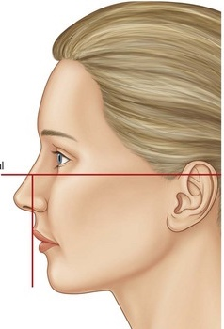
Chin augmentation is slowly growing in popularity. In the ideal female profile when a straight line is drawn down from the upper lip, the lower lip sits 2mm behind, and the chin 4mm behind this line. With males the ideal chin position is slightly more forward. A retrusive or weak chin may be more apparent and exaggerate a large forward projecting nose and may make jowls and sub-mental excess appear more marked. Chins can be augmented by the injection of fillers or fat when only very modest corrections are required, or by surgery for more significant corrections. Surgical corrections can either be through a genioplasty where the bone of the mandible is divided and a metal plate applied to fix it in a more forward position, or by the introduction of a usually semi-solid silicone implant. Mr Cadier perform chin augmentation through implant insertion.

Pre-operative advice.

In order to optimize the result and minimize the risks a number of factors should be considered. Smokers have a much higher risk of developing complications. It is therefore advised that they should refrain from smoking for ideally four weeks prior to, and four weeks following surgery. Aspirin and related anti-inflammatories (other than those prescribed during the admission) should be avoided for one week before and 48 hours after surgery as these can significantly increase the risk of bleeding. Many supplements (gingko, ginger, turmeric, garlic) have anti-coagulant effects and therefore can increase the risk of bleeding and bruising and should be discontinued for a similar time period. The use of arnica is debatable with no clear evidence to support either its use or its avoidance. It is recommended that patients on the combined oral contraceptive, and hormone replacement therapy, should stop these for four weeks prior to, and four weeks after surgery, as they may be associated with an increased risk of deep vein thrombosis (DVT). For patients on the pill alternative forms of contraception should be used. Patients who are overweight also have a higher risk of complications. If patients are dieting, they should aim to get to their desired weight pre-operatively. Mr Cadier and his team have the policy that such surgery will only be offered to patients with a Body Mass Index (BMI) of less than 36. The BMI is calculated from the weight and height, and there are many simple tools available on the internet to help perform this calculation. Patients with a BMI of 36 or over have much higher risks both from the surgery and the anaesthetic and the risks therefore potentially outweigh the benefits.

What happens before the operation?

At the initial consultation with Mr Cadier after discussing regarding the specific concerns a full medical and surgical history will be obtained. As part of the consultation a psychological assessment is made to ensure that it is appropriate to undertake the surgery, and on occasions the completion of a psychological questionnaire may be required. In all cases Mr Cadier will write to the GP to request a past medical history. Patients may refuse this but need to be aware they are exposing themselves to more risks should they omit or forget some relevant past medical history. Also, in the post-operative period should there be any problems it is important that the GP is aware what has been undertaken in order to be able to offer effective help and advice. At the consultation details regarding the operation, the aims, the limitations, the recovery and the risks will be discussed. Before the operation you will usually attend for a pre-operative nurse led assessment. You may require a blood test. Any significant health problems not previously identified may be discussed with Mr Cadier or the anaesthetist, and a further assessment may be required to determine suitability for the procedure.

At admission you will again be assessed by the nurses and you will be measured for a pair of compression stockings. These are worn to reduce the risk of thrombosis formation and should be worn for a minimum two weeks post-operatively. You will be seen by the anaesthetist prior to surgery and be able to discuss issues pertaining to the anaesthetic and also pain relief in the immediate post-operative period. You will also see Mr Cadier who may make some pre-operative markings and will take photographs for the medical records.
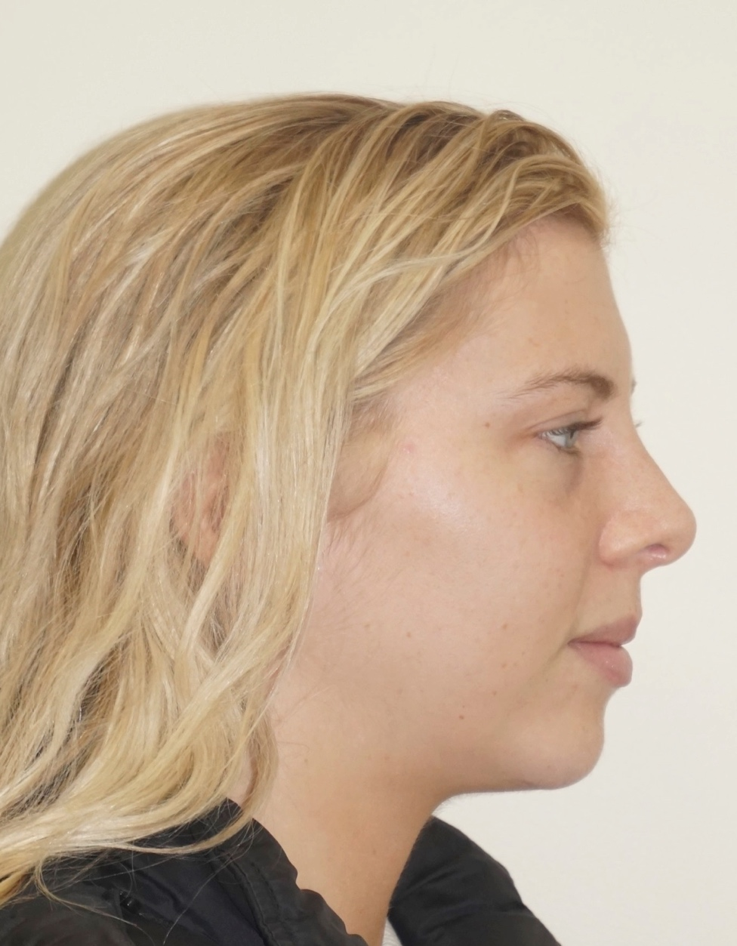
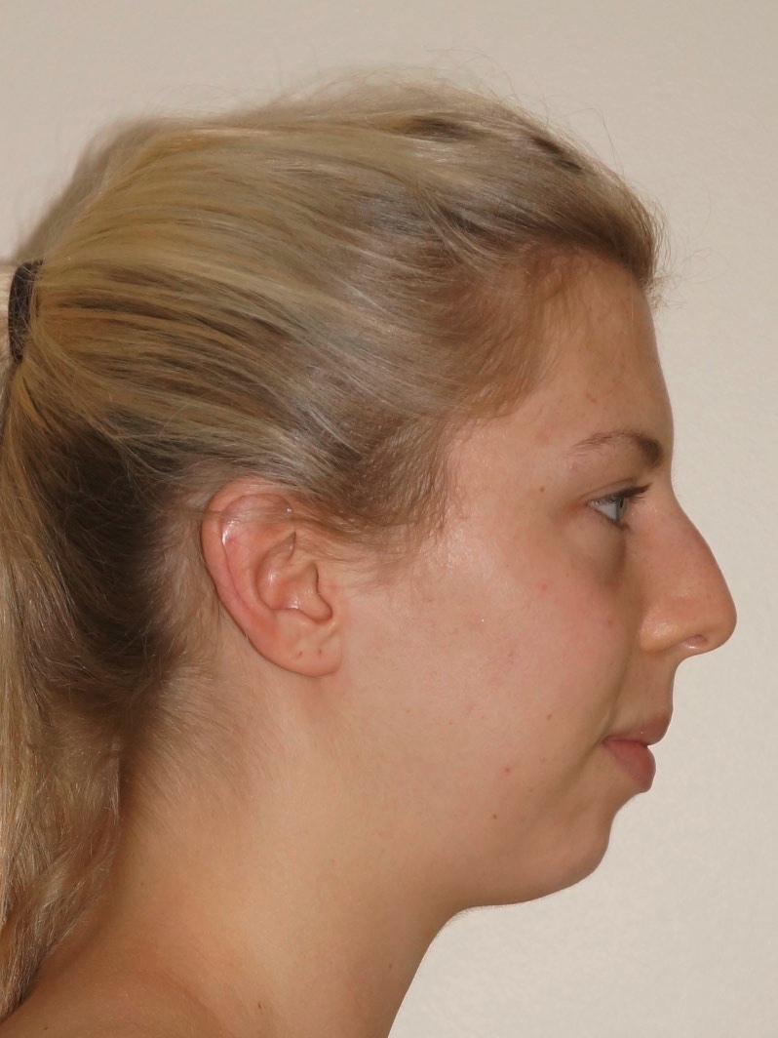
Pre and 6 month post-operative views after chin augmentation and open septorhinoplasty

The operation.

The operation of chin augmentation is undertaken under general anaesthesia and usually takes approximately 45 minutes. The operation is undertaken on the day of admission and patients stay in hospital either as a daycase or for one night following surgery.

The incision.

The incision can either be made inside the mouth in the gum margin under the lower teeth (a buccal sulcus incision), or in the crease under the chin (a sub-mental incision). The advantage of the buccal sulcus approach is that there is no external scar but fixing the implant in position is more difficult and the implant may be prone to moving upwards over the course of time. The sub-mental approach does leave a scar, but it is short and in a very concealed position. The sub-mental approach allows fixation of the implant to the bone and thus a more predictable long-term outcome.

The implant types.

There is a very large range of silicone chin implants available. These vary not only in the amount of projection but also in how far around the jaw they extend. This will be discussed at the initial consultation.

Post-operative course

Following surgery, the chin may be covered with Elastoplast tape to reduce swelling and keep the implant in the right position. If a buccal approach (inside the mouth) is used the stitches are dissolving, with a sub-mental approach they usually need to be removed at 2 weeks. Pain is usually minimal and simple analgesia alone is required. Some swelling and tightness is inevitable and usually settles after a few days. There may be altered sensation in the area for a few weeks. You will be reviewed at 1 and 2 (if suture removal is required) by the specialist cosmetic nursing staff and by Mr Cadier in out-patients at 1 and 5 months post-operatively.

Activities.

For the first 48 hours following surgery patients are advised not to drive because of the general anaesthetic. Most patients take a few days off work however, some patients where work involves a lot of manual activities including heavy lifting may require a longer period of time. Advice regarding this will be given at the initial consultation. Sporting activities including gym work, tennis and badminton should be avoided for between four and six weeks following surgery.

Risks and complications.

As with all surgery complications can occur. Fortunately, with chin augmentation they are relatively uncommon and, in most cases, can be resolved with no significant longterm effects. These are listed below:

- Soft tissue problems:
    - Haematoma (rare)
    - Infection (1:50 risk)
    - Capsules (rare) – scar tissue build up leading to hardness of the implant
    - Poor scar (rare)
    - Skin necrosis (very rare)
- Technical problems:
    - Too small, too large
    - Malposition
    - Migration
- Nerve injury:
    - Rare with implants, much more common with bone advancement.
    - Recovers in most cases in 2 months
- Muscle problems (implants only; rare with sub-mental approach):
    - Chin droop
    - Mentalis dysfunction – the muscle in the chin may contract differently
    - Lower lip retraction
- Bone and Teeth
    - Root damage – only with bone advancement.
    - Bone resorption
- General
    - Deep vein thrombosis and life-threatening pulmonary embolism
    - Anaesthetic complications – these will be discussed with you by the anaesthetist before surgery.
    - Death

In the first few hours following surgery bleeding may occur such that a collection of blood accumulates around the implant. The chin swells massively, and patients need to return to the operating theatre for evacuation of the blood (haematoma) and cautery of any bleeding points. There are no longterm sequelea.

Infections around the chin implant usually occur at 2-4 weeks following surgery. The chin swells, becomes painful and red and in some cases there is a purulent discharge from the wound. Patients need to return to the operating theatre for a washout of the wound and in most cases the implant will need to be removed. After 3-4 months once everything has settled down it can be replaced. Fortunately, this is a rare complication.

Occasionally the implant sits in the wrong position. This may be due to a technical error or adverse scarring or a pre-existing asymmetry. In some cases when an undesirable appearance results the implant needs to be re-positioned though this is usually deferred for several months as the implant may re-position itself into the correct place spontaneously as the swelling dissipates.

In some patients there will be a small scar under the chin. In most cases this fades and becomes very inconspicuous over time. Very occasionally in some patients, especially those with very pale skin the scar may become raised and red and may take many months to settle, sometimes requiring some scar treatment to speed up the process. In patients with a coloured skin the colour of the scar may be paler or darker than the surrounding skin rendering it more conspicuous.

When a chin implant is inserted the body will automatically put a layer of scar tissue (a capsule) around the implant. In most cases this is of no consequence. However, very rarely, in some patients, for reasons not fully understood, the scar tissue thickens and squeezes the implant. This is termed capsular contracture. This may occur at any stage following the procedure, though it is unusual in the first year. In many cases it is manifest by firmness of the implant, but in severe cases the implant becomes hard and painful and the shape is distorted. The treatment is surgical, and patients should be aware that they would be liable for treatment costs. Chin implants can occasionally not stay where they are placed, usually going upwards. A surgical correction may be required. If this occurs within 6 months of the surgery there would be no charge, however, beyond this time a charge would be incurred. Fortunately, this is not very common and, in most cases, occurs rapidly.

Following any surgery there is a risk in developing a deep vein thrombosis (DVT). This is a clot in the calf vein of the leg. In itself it may result in pain and swelling. The risk is that should the clot separate from the vein it can move to the lungs resulting in a pulmonary embolism. This is a potentially life-threatening situation. All attempts are made to reduce the risk using compression stockings during and for two weeks after surgery, using pneumatic compression devices on the legs at surgery and in the immediate post-operative period, by encouraging early mobilization, advising patients to stop the combined oral contraceptive pill or Hormone Replacement Therapy (HRT) four weeks prior to surgery, and where it is felt appropriate using injections of blood thinning agents.

All surgical and anaesthetic procedures have risks, and some are life threatening, these include pulmonary embolism, anaphylaxis (severe allergic response to a medication) and adverse drug reactions. Death however remains an extremely rare complication.

Risks and complications will be discussed, and all efforts made to minimize any risks. Patient safety is always our first concern.

When complications do occur, all attempts are made not only to remedy the problem in as speedy a manner as possible but also to optimise the final result. As with all cosmetic surgical procedures undertaken by Mr Cadier, there is a fixed fee policy, which means that no further charges are incurred for the treatment of complications that are identified within 6 months following the initial surgery. Revisional policies for aesthetic concerns have changed and, in most cases, additional fees will be incurred. Patients need to be aware regarding the limitations of surgery and have very realistic expectations about outcomes.

Longterm advice

There is very little long term data on chin implants however, there is no reason to change them unless there is a problem, and in many cases the correction is permanent. With complications and problems early identification and prompt intervention is important and should patients have any cause for concern they should either contact the hospital or Mr Cadiers’ secretary, the contact details being shown below.

Contact details:

Private Office:

Address: 36 Batten Road, Downton, Salisbury, SP5 3HU
PA: Nicola Haicalis
Ph: 01725 511 550
Fx: 01725 511 846
Email: nicola.haicalis@michaelcadier.com

Website : www.michaelcadier.com

Hospitals :

Nuffield Bournemouth, 67 Lansdowne Rd, Bournemouth Dorset, BH1 1RW.
Tel: 01202 291866

Spire Southampton Hospital, Chalybeate Close, Southampton, Hampshire, S016 6UY.
Tel : 02380 775544

About your Surgeon:

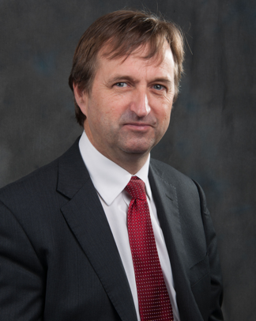
Michael Cadier was educated at the French Lycée in London, studied at Oxford University and undertook Medicine at St Thomas’ Hospital, London. After training in London, Salisbury and Bristol he became an NHS Consultant in the Supra-regional Plastic Surgery Unit in Salisbury in 1996, becoming Head of this Service in 1999. In his NHS practice he developed a breast reconstruction service in Portsmouth, and in 2000 was appointed as cleft surgeon to the newly established Spires Cleft Centre, for which he also became the first Clinical Director in 2002. He undertook yearly cleft lip and palate Charity missions in rural Pakistan from 1996 to 2009. He has a busy aesthetic surgery private practice along the South Coast, undertaking the full range of aesthetic surgery procedures. He has performed over a thousand facelifts, and over 1500 breast augmentations, with similar numbers for all of the more common aesthetic procedures. In 2015 he became fully private, concentrating solely on aesthetic surgical practice.

He is widely published and lectures and teaches on aesthetic surgery both nationally and internationally. In 2006 he was invited to become an examiner for the FRCS (Plast). He is the Program Director for the South Coast Reconstructive Cosmetic Surgery Fellowship, was part of the first UK delegation in the CEN in cosmetic surgery (European regulation) and chaired the CSIC Royal College committee on Clinical Quality and Outcomes in Cosmetic Surgery.

The British Association of Aesthetic Surgeons (BAAPS) is the leading organization for aesthetic surgery in the UK. He was elected to BAAPS Council in 2006 and was President of BAAPS from 2014 to 2016. One of his key objectives is to ensure that UK plastic surgeons of the future will practice aesthetic surgery to the highest possible and with that aim he has helped establish a comprehensive national training program in aesthetic surgery.

