Mr Michael Cadier

BA MA (Oxon) MBBS (London) MS (Soton), FRCSEd, FRCS (Plast) President of BAAPS 2014-2016
Consultant in Plastic, Reconstructive & Aesthetic Surgery

Arm Reshaping (Brachioplasty)

The ideal upper arm shape has a slight convexity its upper outer aspect, and when held out to the side the underneath is smooth with no laxity. In some patients a fold of skin may develop under the arm – the so-called “bingo-wing”. This frequently occurs following large weight reduction but may also occur in a slim person with increasing age and consequent increasing skin laxity. In other patients there is a global excess of fatty tissue distorting the arm shape.

Arm reduction (brachioplasty) surgery has increased in popularity over the last few years partly because techniques have improved but also because of the increasing demand in people who have lost a lot of weight. The surgery aims to correct the flap of redundant skin and tissue seen under the upper arm when held out to the side. There are several techniques for arm reduction as described below.

What types of arm reductions are available?

There are several different techniques for arm reduction. In a younger patient with relatively taut skin liposuction alone may be employed. When the skin is not taut liposuction can make matters worse by increasing the apparent skin excess. Liposuction is however, frequently used as an adjunct in arm reduction procedures to fine tune the arm shape. The most common form of arm reduction is to directly excise the overhanging fold of tissue. This leaves a scar that is concealed under the arm and runs from the elbow to the armpit. In

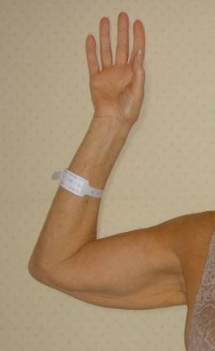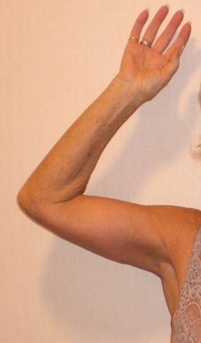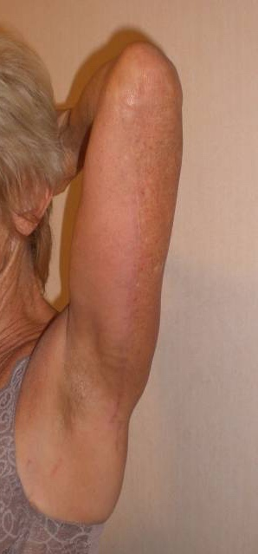

some patients the excision is extended down the side of the trunk towards the bra strap line to excise excess tissue around the armpit.

The short scar arm reduction is a relatively new procedure designed for patients with relatively modest overhangs, and in whom a scar along the underside of the arm would not be acceptable. Tissue is excised from the armpit itself and the arm skin tightened by drawing the skin up towards the armpit, whilst at the same time reducing the bulk of the arm with liposuction. The scar is situated in the armpit, with most of the hair bearing skin being excised. The effect is however quite limited and only suitable in a few cases. Other modifications include excision of tissue around the front of the armpit, or excision of excess tissue from the elbow crease. Very occasionally the arm reduction may include excision of tissue from the forearm. Which of these is suitable is discussed at the initial consultation.

Pre-operative advice.

In order to optimize the result and minimize the risks a number of factors should be considered. Smokers have a much higher risk of developing complications. It is therefore advised that they should refrain from smoking for ideally four weeks prior to, and four weeks following surgery. Aspirin and related anti-inflammatories (other than those prescribed during the admission) should be avoided for one week before and 48 hours after surgery as these can significantly increase the risk of bleeding. Many supplements (gingko, ginger, turmeric, garlic) have anti-coagulant effects and therefore can increase the risk of bleeding and bruising and should be discontinued for a similar time period. The use of arnica is debatable with no clear evidence to support either its use or its avoidance.

It is recommended that patients on the combined oral contraceptive, and hormone replacement therapy, should stop these for four weeks prior to, and four weeks after surgery, as they may be associated with an increased risk of deep vein thrombosis (DVT). For patients on the pill alternative forms of contraception should be used.

Patients who are overweight also have a higher risk of complications, and abdominoplasties should not be seen as a way of losing weight. If patients are dieting, they should aim to get to their desired weight pre-operatively. Mr Cadier and his team have the policy that such surgery will only be offered to patients with a Body Mass Index (BMI) of less than 36. The BMI is calculated from the weight and height, and there are many simple tools available on the internet to help perform this calculation. Patients with a BMI of 36 or over have much higher risks both from the surgery and the anaesthetic and the risks therefore potentially outweigh the benefits.

What happens before the operation?

At the initial consultation with Mr Cadier after discussing regarding the specific concerns a full medical and surgical history will be obtained. As part of the consultation a psychological assessment is made to ensure that it is appropriate to undertake the surgery, and on occasions the completion of a psychological questionnaire may be required. In all cases Mr Cadier will write to the GP to request a past medical history. Patients may refuse this but need to be aware they are exposing themselves to more risks should they omit or forget some relevant past medical history. Also, in the post-operative period should there be any problems it is important that the GP is aware what has been undertaken in order to be able to offer effective help and advice. At the consultation details regarding the operation, the aims, the limitations, the recovery and the risks will be discussed. Before the operation you will usually attend for a pre-operative nurse led assessment. You may require a blood test. Any significant health problems not previously identified may be discussed with Mr Cadier or the anaesthetist, and a further assessment may be required to determine suitability for the procedure.

At admission you will again be assessed by the nurses and you will be measured for a pair of compression stockings. These are worn to reduce the risk of thrombosis formation and should be worn for a minimum two weeks post-operatively. You will be seen by the anaesthetist prior to surgery and be able to discuss issues pertaining to the anaesthetic and also pain relief in the immediate post-operative period. You will also see Mr Cadier who may make some pre-operative markings and will take photographs for the medical records.

The operative procedure.

The surgery takes 1½ to 2 hours to perform and is undertaken under general anaesthesia with patients usually being in hospital for 1-2 nights postoperatively.

What to expect immediately after the operation

Your blood pressure and pulse will be taken regularly following your return to the ward. You will have an intravenous infusion (a drip) which is usually removed after 24 hours once you are able to tolerate diet and fluids comfortably. If you experience any pain or discomfort following surgery painkillers are given either by injection or as tablets. Drains are occasionally placed into each arm to allow any oozing or bleeding to accumulate into either a small bottle or bag by the side of the bed. These are usually removed prior to discharge.

Dressings/Pressure garments.

Following the arm reduction procedure dressings are applied in the operating theatre as follows: butterfly tapes are applied directly to the wound and then an absorbent dressing is placed over this. These dressings are usually left intact for seven days following surgery unless they become messy, in which case they are changed prior to discharge. In the armpit region the wounds may be left exposed as dressings will not adhere and will become dislodged. Patients are invited to re-attend 7 and 14 days post discharge for a wound check by the nursing staff and a change of dressings. Dressings are then required twice a week for a total of about two to three weeks following surgery. The tapes that are applied directly to the wound should be left longer if possible. Some patients are advised to wear some form of pressure dressing for up to 6 weeks following surgery not only to aid in reducing swelling but also to help re-shape the arm. There are several types of garment available. This will be discussed at the initial consultation.

Wound care and stitches.

The wound should be kept dry whilst the dressings are in place and during this period of time patients are advised to wash around the area with a flannel. With the waterproof dressing patients can shower however, these should be brief and as best possible the dressing should be kept away from the water. After this period the patients can get the wound wet provided there are no significant wound problems. Prolonged soaking in a bath should be avoided for at least three weeks postoperatively. There are usually no sutures that need to be removed, as the suture is self-dissolving. Occasionally a knot or end of suture may appear on the wound line. These are best left to self-separate unless they are causing a problem.

Scar maturation.

The scars will inevitably go red, become lumpy and may widen. After two to four weeks when healed, massaging two times a day with Vitamin E containing ointment is advised. This should be continued for at least 2 months following surgery, and longer if the scars are not settling. Full scar maturation may take 6 – 24 months. Ultimately the scars will in most cases become pale and flat, however if this process is delayed other treatments including silicone therapy, steroid injections and laser treatment may be required. In rare cases a scar revisional procedure may be beneficial, though this will set the clock back in terms of scar maturation. In patients who have undergone a short scar procedure the scar in the armpit may appear very wrinkled at first. This is normal. The wrinkling will gradually dissipate over several weeks. Additionally, with short scar reductions as the scar is in the armpit minor infections are very common and delayed wound healing is not unusual.

What to expect/pain relief.

Pain is not usually marked although regular pain relief with simple analgesics is often required for 7 to 10 days postoperatively. The arm will inevitably feel tight for several days owing to swelling. Additionally, shoulder and elbow movements may be restricted for 2 to 4 weeks. This may lead to difficulties in certain activities – combing the hair, putting contact lenses in and out – during this time. Some numbness around the scar and in the forearm is common and is not a cause for concern – it will usually resolve over time. Wound infections are not uncommon and may lead to a slight prolongation of the time required for dressings and occasionally need antibiotic treatment.

Restrictions.

For the first one to two weeks following surgery patients should rest and convalesce. They should refrain from driving or from undertaking any light housework. After this period light housework and gentle activities can be undertaken, gradually building up to normal over a six to eight week period. Gentle gym activities and jogging can be resumed at 3-4 weeks however heavy lifting or any vigorous sporting activities (aerobics, tennis, and badminton) should be avoided for two to three months following surgery as undue pressure on the wound may have an adverse effect on scarring. Most patients refrain from work for 1-2 weeks, however in those with physical jobs or whom recovery is delayed an additional 1-2 weeks may be required.

Follow up.

After discharge patients require a wound check usually 7 and 14 days post discharge. This can either be by the nursing staff in the outpatients where the surgery was undertaken. Dressings are then required for two to three weeks postoperatively. Appointments for the initial dressing change are made prior to discharge. You will also be reviewed by Mr Cadier at one and five months postoperatively. These appointments will be sent in the post.

Risks and complications.

As with all surgical procedures complications may occur. These include:

- Anaesthetic risks (these will be discussed with you before surgery by the anaesthetist
- Bleeding resulting in a haematoma
- Infection
- Poor wound healing
- Wound breakdown requiring revisional surgery including the use of skin grafts
- Poor scarring including hypertrophic and keloid scarring
- Fluid accumulation (seroma)
- Asymmetry or bulges
- Damage to deeper structures such as nerves, blood vessels and muscles
- Fatty tissue under the skin might die (fat necrosis)
- Numbness or other changes in skin sensation
- Pain, which may persist
- Persistent swelling (lymphoedema)
- Sutures and dissolving buried staples may not absorb, but spontaneously surface through the skin, causing irritation, drainage and redness
- Possible need for revisional surgery

- Deep vein thrombosis and life-threatening pulmonary embolism
- Anaesthetic complications – these will be discussed with you by the anaesthetist before surgery.
- Death

In the first few hours on returning to the ward bleeding may occur and this can accumulate resulting in a haematoma. The arm becomes swollen and patients need to return to the operating theatre for evacuation of the haematoma. This occurs in about 1:100 cases. There are usually no long-term sequelea.

The commonest complication is wound infection. Occasionally antibiotics are required, and dressing may be required for a longer period. In severe infections wounds can breakdown. This is a relatively unusual complication in non-smokers, and patients of normal body weight. Patients who do smoke should refrain for 4 weeks before and at least 4 weeks after surgery. Usually the wounds will heal with simple dressings alone, though occasionally secondary surgery may be required – including the possible use of skin grafts.

The biggest concern with arm reduction surgery is the inevitable scar that results. All attempts are made to keep this as inconspicuous as possible – by careful placement, meticulous tissue handling and multilayered suturing. Nonetheless the pattern of scarring is very variable between patients and in some the scar becomes red and lumpy (hypertrophic and keloid scarring). In most cases it is best to adopt a wait and see policy but in some other treatments such as silicone dressings, steroid injections and scar revisions may help.

Sensory disturbance to the arm and forearm skin is common and will usually resolve spontaneously over several months. Some permanent numbness around the scar is inevitable. Some pain and discomfort will occur but usually resolves after a week or two.

All attempts are made to make the arms the same in terms of size and shape and scar position however small differences are almost inevitable. If marked, then revisional surgery may be required though this is usually deferred for several months as some differences may reduce as all the swelling settles.

Following any surgery there is a risk in developing a deep vein thrombosis (DVT). This is a clot in the calf vein of the leg. In itself it may result in pain and swelling. The risk is that should the clot separate from the vein it can move to the lungs resulting in a pulmonary embolism. This is a potentially life-threatening situation. All attempts are made to reduce the risk using compression stockings during and for two weeks after surgery, using pneumatic compression devices on the legs at surgery and in the immediate post-operative period, by encouraging early mobilization, advising patients to stop the combined oral contraceptive pill or Hormone Replacement Therapy (HRT) four weeks prior to surgery, and where it is felt appropriate using injections of blood thinning agents.

All surgical and anaesthetic procedures have risks and some are life threatening, these include pulmonary embolism, anaphylaxis (severe allergic response to a medication) and adverse drug reactions. Death however remains an extremely rare complication.

When complications do occur, all attempts are made not only to remedy the problem in as speedy a manner as possible but also to optimise the final result. As with all cosmetic surgical procedures undertaken by Mr Cadier, there is a fixed fee policy, which means that no further charges are incurred for the treatment of complications that are identified within 6 months following the initial surgery. Revisional policies for aesthetic concerns have changed and, in most cases, additional fees will be incurred. Patients need to be aware regarding the limitations of surgery and have very realistic expectations about outcomes.

Most patients are delighted with the result of surgery and arm reductions are associated with high rates of patient satisfaction. Patients find that they are no longer embarrassed by the flap of tissue under the arm and will be able to wear short sleeves without feeling self-conscious.

Contact details:

Private Office:

Address: 36 Batten Road, Downton, Salisbury, SP5 3HU
PA: Nicola Haicalis
Ph: 01725 511 550
Fx: 01725 511 846
Email: nicola.haicalis@michaelcadier.com

Website : www.michaelcadier.com

Hospitals :

Nuffield Bournemouth, 67 Lansdowne Rd, Bournemouth Dorset, BH1 1RW.
Tel: 01202 291866

Spire Southampton Hospital, Chalybeate Close, Southampton, Hampshire, S016 6UY.
Tel : 02380 775544

About your Surgeon:

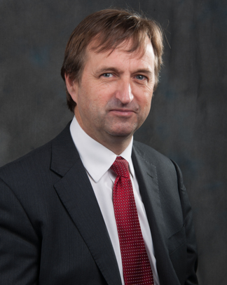
Michael Cadier was educated at the French Lycée in London, studied at Oxford University and undertook Medicine at St Thomas’ Hospital, London. After training in London, Salisbury and Bristol he became an NHS Consultant in the Supra-regional Plastic Surgery Unit in Salisbury in 1996, becoming Head of this Service in 1999. In his NHS practice he developed a breast reconstruction service in Portsmouth, and in 2000 was appointed as cleft surgeon to the newly established Spires Cleft Centre, for which he also became the first Clinical Director in 2002. He undertook yearly cleft lip and palate Charity missions in rural Pakistan from 1996 to 2009. He has a busy aesthetic surgery private practice along the South Coast, undertaking the full range of aesthetic surgery procedures. He has performed over a thousand facelifts, and over 1500 breast augmentations, with similar numbers for all of the more common aesthetic procedures. In 2015 he became fully private, concentrating solely on aesthetic surgical practice.

He is widely published and lectures and teaches on aesthetic surgery both nationally and internationally. In 2006 he was invited to become an examiner for the FRCS (Plast). He is the Program Director for the South Coast Reconstructive Cosmetic Surgery Fellowship, was part of the first UK delegation in the CEN in cosmetic surgery (European regulation) and chaired the CSIC Royal College committee on Clinical Quality and Outcomes in Cosmetic Surgery.

The British Association of Aesthetic Surgeons (BAAPS) is the leading organization for aesthetic surgery in the UK. He was elected to BAAPS Council in 2006 and was President of BAAPS from 2014 to 2016. One of his key objectives is to ensure that UK plastic surgeons of the future will practice aesthetic surgery to the highest possible and with that aim he has helped establish a comprehensive national training program in aesthetic surgery.

